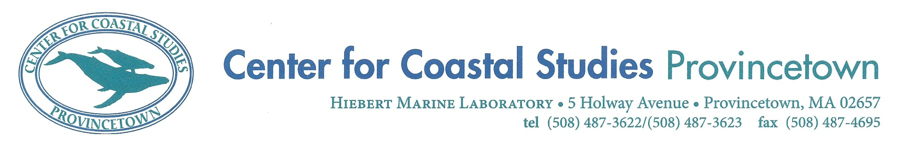

**Right Whale Ecology Program Photo-ID Internship**

**Center for Coastal Studies (CCS), Provincetown, MA USA**

The Center for Coastal Studies (CCS), a nonprofit institution dedicated to the understanding and protection of our coastal environment and marine ecosystems, is seeking a seasonal Right Whale Ecology Program vessel observer and photo-ID intern from January 06, 2025 through May 30, 2025. This long-term project focuses on documenting the abundance, distribution, and behavior of North Atlantic right whales and their food resource in Cape Cod Bay and adjacent Massachusetts waters. The intern will be the primary vessel observer for the project and will participate in research cruises up to four days a week. Fieldwork responsibilities include photographing critically endangered North Atlantic right whales, collecting behavioral and environmental data, recording other sighting events (species, vessels, and fishing gear), and working with a habitat research team both in the field and office. Office responsibilities include photo-analysis (downloading images, inputting sightings information, matching individuals to known animals using an online and in-house catalog), database entry and maintenance, assisting the aerial team, and maintaining vessel field equipment.

**Minimum Requirements:**

* Previous marine mammal survey experience, including background in species identification and photo-identification of large cetaceans;
* Experience with digital SLR cameras, lenses, and filters;
* Basic computer literacy and working knowledge of Microsoft Office programs (Excel, Word, PowerPoint);
* Experience working on boats and ability to withstand harsh elements for up to 10 hours at a time;
* Not prone to serious seasickness;
* Ability to live and work well in a team;
* Enthusiasm and willingness to learn field and lab-based research methods;
* Strong attention to detail and ability to work well under pressure.

**Preferred Qualifications:**

* Bachelor’s degree, preferably in biological/environmental sciences;
* Experience using iMatch image database software;
* Experience with database entry and management;
* Experience using GPS equipment;
* Demonstrated ability to estimate object distance ranges from a vessel;
* A valid US driver’s license.

The successful applicant will be required to work a minimum of five full days per week and will need to be flexible for research cruises due to weather constraints. The intern will often collect data independently in the field; thus responsible, detail-oriented applicants are encouraged to apply. Applicants must be available for the full field season and must be willing to work weekends, holidays, and evenings as needed. Housing will be provided, as well as a $15 hourly rate of pay. International applicants must secure their own visas or other required documentation.

CCS has a long history of conservation and research work with the North Atlantic right whale, and Cape Cod Bay has been a major critical habitat for around 50% of the estimated population in recent years. This is an excellent opportunity for anyone wishing to expand their skills in marine mammal survey techniques and will offer the successful applicant the unique chance to work with one of the world’s most endangered cetaceans. This internship will afford the successful applicant an invaluable opportunity to work within a well-established institution, with highly-qualified scientists, and to gain experience in photo-identification, matching, and data entry and analysis. Experience in oceanographic sampling can also be gained. Details of our work can be found on our website:

<http://coastalstudies.org/right-whale-research/>

**How to Apply:**

The application package should include the following as a single PDF:

1. Cover letter describing your specific interests in marine mammal science, internship qualifications, and how the experience would assist you in reaching career goals;
2. CV/resume;
3. The names and contact information of two references;
4. College transcripts, if applicable (unofficial are sufficient).

Application materials must be e-mailed to: employment@coastalstudies.org with the subject line: **2025 RW Photo-ID Internship**.

**Deadline for submissions: September 20th, 2024.**

**The Center for Coastal Studies is an Equal Opportunity Employer and encourages candidates of all backgrounds to apply.**

**Diversity of opinions, experience, and backgrounds is a key asset.**

**The Center for Coastal Studies is an Equal Opportunity Employer**

**and encourages candidates of all backgrounds to apply.**

**Diversity of opinions, experience, and backgrounds is a key asset.**