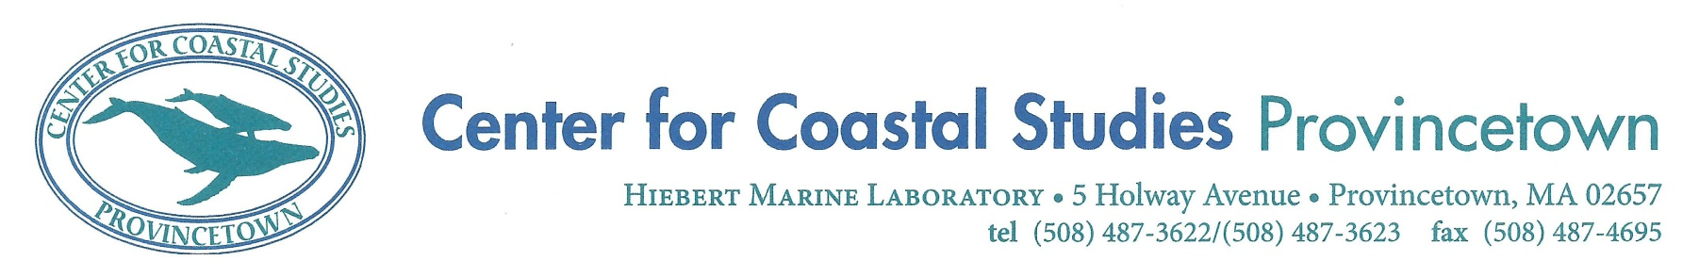

**Right Whale Ecology Program**

**Habitat Internship Announcement**

The Center for Coastal Studies (CCS), a nonprofit institution dedicated to the understanding and protection of our coastal environment and marine ecosystems, is seeking a seasonal Right Whale Ecology Program intern from **January 06 - May 30, 2025**. This long-term project focuses on documenting the abundance, distribution, and behavior of North Atlantic right whales and their food resource in Cape Cod Bay and adjacent Massachusetts waters. The intern will assist the habitat research associate in the collection and processing of zooplankton in the field and lab. Fieldwork responsibilities include zooplankton collection through tow and pump techniques, marine observer, and environmental data collector. Lab responsibilities include zooplankton species identification and counts, plastics analysis, archiving samples, data entry and maintenance, and maintaining field equipment.

Minimum Requirements:

* A Bachelor’s degree, preferably in biological/ environmental sciences;
* Good memorization skills and strong attention to details;
* Basic computer literacy and experience using Microsoft Office programs (Excel, Word, PowerPoint). Experience with database entry and management is preferred;
* Experience working on boats, ability to withstand harsh elements, and not be prone to serious seasickness;
* Must be able to live and work well in a team;
* Enthusiasm and willingness to learn field and lab-based research methods;
* Ability to work well under pressure.

Preferred Qualifications:

* Plankton identification;
* Microscopy experience;
* Vessel observer experience;
* Not prone to seasickness;
* A valid US driver’s license.

The successful applicant will be required to work a minimum of five full days per week and will need to be flexible for research cruises due to weather constrictions. The intern will often process zooplankton samples independently in the lab, thus responsible, detail-oriented applicants are encouraged to apply. Applicants must be available for the full five months and must be willing to work weekends, holidays and evenings as needed. Housing will be provided, as well as a $15 hourly rate of pay to cover expenses. International applicants must secure their own visas or other required documentation.

CCS has a long history of conservation and research work with the North Atlantic right whale and Cape Cod Bay has been a major critical habitat for over 50% of the estimated population in recent years. This is an excellent opportunity for anyone wishing to expand their skills in marine mammal survey techniques and zooplankton analysis; and will offer the successful applicant the unique chance to work with one of the world’s most endangered cetaceans. This internship will afford the successful applicant an invaluable opportunity to work within a well-established institution, with highly-qualified scientists, and to gain experience in boat-based research, zooplankton and environmental collections, plankton identification, plastic analysis, and data entry and analysis. Details of our work can be found on our website: http://coastalstudies.org/right-whale-research/.

**How to Apply:**

The application package should include **one pdf** that includes the following:

1. A cover letter describing your specific interests in marine mammal science, internship qualifications, and how the experience would assist you in reaching career goals;
2. CV/Resume;
3. The names and contact information of three professional references.

Application materials must be e-mailed to: **Employment@coastalstudies.org** with

the following text in the subject line: **2025 RW habitat internship**.

**Deadline for submissions: September 3rd, 2024.**

**The Center for Coastal Studies is an Equal Opportunity Employer**

**and encourages candidates of all backgrounds to apply.**

**Diversity of opinions, experience, and backgrounds is a key asset.**