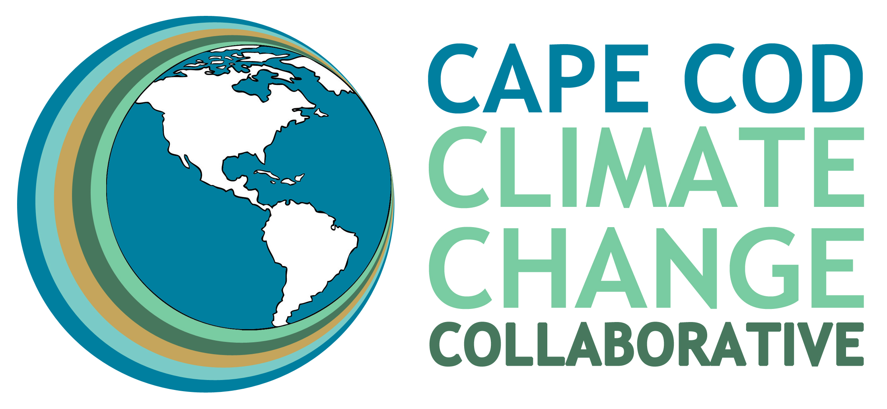

Contact: Fran Schofield or Bonnie McEwan
Phone: 508.237.0006; 917.693.0940
Email: fran@capecodclimate.org or bonnie@capecodclimate.org
Website: www.capecodclimate.org

Press Advisory

CAPE COD CLIMATE CHANGE COLLABORATIVE TO HOLD VIRTUAL EVENT
ORGANIZING FOR LOCAL CLIMATE ACTION
Get inspired, organized and active to effect real “climate change” in your town
YARMOUTH, MASS. March 4, 2022. The Cape Cod Climate Change Collaborative (Climate Collaborative) announced the launch of its 2022 Climate Conversations event series with the webinar Organizing for Local Climate Action: Stories from the Cape & Islands. The virtual event is scheduled for Friday, March 18, 2022, from 12:00 to 1:30PM. Attendees may register, free of charge, on the Climate Collaborative website at: https://capecodclimate.org/webinars/.
With climate change bearing down on our planet and the Cape & Islands region in particular — imperiling lives, health, economy, environment, and entire ways of life — climate action at the local level is imperative. But how and where to begin? Four local climate activists — from Aquinnah, Chatham, Falmouth, and Truro — will share their stories about getting started, how they are making a difference in their communities, and how other interested citizens can too!

Climate Collaborative board president Rich Delaney will host the event, and former Mass. Sen. Rob O’Leary (Cape & Islands) will serve as moderator. “While federal, state and regional public policy makers have made significant progress in recent years, it’s really at the local level where the rubber meets the road. We can’t address the climate crisis without making immediate and substantive changes in local practices, policies, and bylaws,” Delaney says. “Mitigating climate change needs all hands on deck,” O’Leary adds. Concerned citizens, students, seasoned and novice climate advocates, town committee members, selectboards, faith community members, and elected officials throughout the Cape & Islands region and the Commonwealth are invited to attend and join the conversation.
The webinar features a moderated panel discussion with local climate activists Rosemary Carey, Carol Harris, Noli Taylor and Janet Williams of Falmouth, Truro, Aquinnah and Chatham, respectively. Each will share stories about their “beginnings” as citizen activists, describe lessons they’ve learned, share what worked (and what didn’t), and discuss their groups’ accomplishments, large and small. They will also discuss the importance of citizen involvement in town committee work and how collaboration with town departments, committees, businesses, and nonprofits is essential to making change at the local level. The webinar will offer a Q&A opportunity followed by a wrap up by Fran Schofield, co-vice president of the Climate Collaborative board of directors, who will discuss resources and support offered by the Climate Collaborative and partners to help move the climate needle throughout the region.
The Cape Cod Climate Change Collaborative is a non-profit 501 (c)(3) organization whose mission is to reduce ways in which the Cape & Islands region contributes to climate change and to protect our region from its potentially devastating impacts. The all-volunteer organization is governed by a board of directors and welcomes the participation and financial support of its stakeholders. Visit capecodclimate.org for more information and learn how to get involved.

Cape Cod Climate Change Collaborative
P.O. Box 46, Yarmouth Port, MA 02675
capecodclimate.org | capecodclimate@gmail.com

