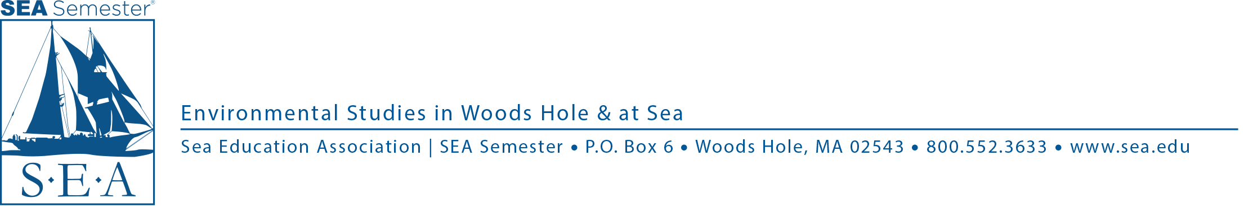

# 

**For Immediate Release: April 25, 2019**

Contact: Doug Karlson, Marketing & Communications Coordinator

508-444-1918 | [dkarlson@sea.edu](mailto:dkarlson@sea.edu) | www.sea.edu

**SEA to Host Public Lecture on Environmental Lessons of *Moby-Dick***

Sea Education Association (SEA) will host a public lecture, “Did the Whale Diminish?,” examining what *Moby-Dick* teaches us about today’s eco guilt, extinction, and whale populations, on Sunday, May 19, at 2 pm. Richard King, visiting associate professor at SEA, will deliver the lecture, the second of SEA’s Spring Lecture Series. The lecture will be held at James L. Madden Center Lecture Hall, Sea Education Association, 171 Woods Hole Road, Falmouth. It is free and open to the public. Light refreshments will be served.

**About the Lecture**

America's most famous and profound work of sea fiction provides an ideal benchmark for our perception of the ocean at the opening of the Anthropocene. Herman Melville was not only an avid reader of sea narratives and natural history texts of the 1850s, but he spent more than three years at sea in the Pacific, much of that time hunting whales. As we approach Melville’s 200th birthday, this presentation examines Melville's understanding, only a few years before *On the Origin of Species,*of extinction and the reduction of sperm and right whale populations and individual size in response to human hunting. We compare this to what whale biologists have traced since - and what effect this has on our collective psyche, our "eco-guilt," and our motivation to act.

**About the Lecturer**

Richard King is a visiting associate professor at SEA, who focuses on the intersections between sea voyage narratives, environmental history, and marine biology. He's the author of*Lobster; The Devil's Cormorant: A Natural History;* and the forthcoming *Ahab's Rolling Sea: A Natural History of Moby-Dick.*

**About** [**Sea Education Association/SEA Semester®**](http://www.sea.edu/?utm_source=press_release&utm_medium=email&utm_campaign=lecture)Sea Education Association (SEA) is an internationally recognized leader in undergraduate ocean education. For 45 years and more than one million nautical miles sailed, SEA has educated students about the world’s oceans through its Boston University accredited study abroad program, SEA Semester. SEA/SEA Semester is based on Cape Cod in the oceanographic research community of Woods Hole, Massachusetts and has two research vessels: the SSV *Corwith Cramer*,operating in the Atlantic Ocean, and the SSV *Robert C. Seamans*, operating in the Pacific. In 2016, SEA was honored with the [National Science Board’s Public Service Award](http://www.sea.edu/sea_currents/single/sea_honored_with_national_science_board_award?utm_source=press_release&utm_medium=email&utm_campaign=lecture) for its role in promoting the public understanding of science and engineering. Last year, the National Maritime Historical Society presented Sea Education Association with the Walter Cronkite Award for Excellence in Maritime Education.

| [Twitter](https://twitter.com/sea_semester) ǀ [Facebook](https://www.facebook.com/SEA) ǀ [YouTube](https://www.youtube.com/user/SeaEducationAssn/featured) ǀ [Vimeo](https://vimeo.com/seasemester)|[Instagram](https://instagram.com/sea_semester/)