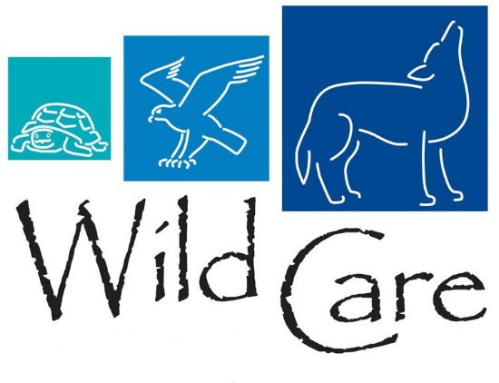

March 25, 2019

FOR IMMEDIATE RELEASE

Contact:

Heather Arrascue

Marketing and Events Assistant, WILD CARE Inc.

508.404.4145, events[@wildcarecapecod.org](mailto:evetns@wildcarecapecod.org)

**Bring the Outdoors Inside - with Wild Care’s “Woodland Botanical Design” Event**

###

*Eastham.* March 25, 2019 Wild Care, a wildlife rehabilitation center located in Eastham, is hosting Jerry Moles of The Flowering Pot as he shares his award-winning design talents with attendees of our Woodland Botanical Design Event on Thursday, April 25th. The event will start at 6 PM, and will be held at [Sea Dog Brew Pub](https://www.seadogcapecod.com), 23 Whites Path in South Yarmouth. A minimum of 25 attendees is required to hold the event, RSVP are required by April 14th, please purchase tickets at [Eventbrite](https://www.eventbrite.com/e/woodland-botanical-design-event-tickets-59169085327).

Attendees will create a one-of-a-kind woodland botanical floral design. All instruction and materials are included in the $65 price. Woodland botanical floral designs capture the essence of an enchanted forest floor, in small scale, utilizing fresh flowers and both living and dried plant material. For more information about the designs, or to see Jerry’s work, please visit: [thefloweringpots.com](https://www.thefloweringpots.com)

“Wild Care is excited to offer this unique event - celebrating spring and all things nature! Our attendees are in for a truly enjoyable evening. They will be supporting Wild Care, *and* taking home a beautiful Woodland Botanical Design”, states Stephanie Ellis, Wild Care’s Executive Director.

###

ABOUT WILD CARE:

Wild Care’s mission is to treat injured, ill and orphaned native wildlife for release, to prevent wildlife casualties through public education and live counseling, and to engage the community in conservation through volunteerism. Since our founding, Wild Care has accepted over 27,000 wild creatures, representing 275 species of native birds, mammals, and reptiles. On average, Wild Care receives over 1,800 wild animals per year for treatment. If you encounter injured, orphaned or ill wildlife please call Wild Care’s “Wildlife Helpline” at 508-240- 2255.

For more information on upcoming Wild Care events [Click Here](https://www.wildcarecapecod.org/category/events/) . Visit our [website](https://www.wildcarecapecod.org/) and like us on [Facebook](https://www.facebook.com/WildCareCapeCod/) to keep up with events and wonderful animal success stories. To make a donation please visit our website:[www.wildcarecapecod.org](http://www.wildcarecapecod.org).