Press Release
July 23, 2018

For Release: IMMEDIATE
Contact: Brendan Buckless, Outreach and Stewardship Coordinator
Brendan@westportlandtrust.org
 days: (508) 636-9228

Anais Mitchell LIVE in Concert at Westport Town Farm
Saturday, August 4th

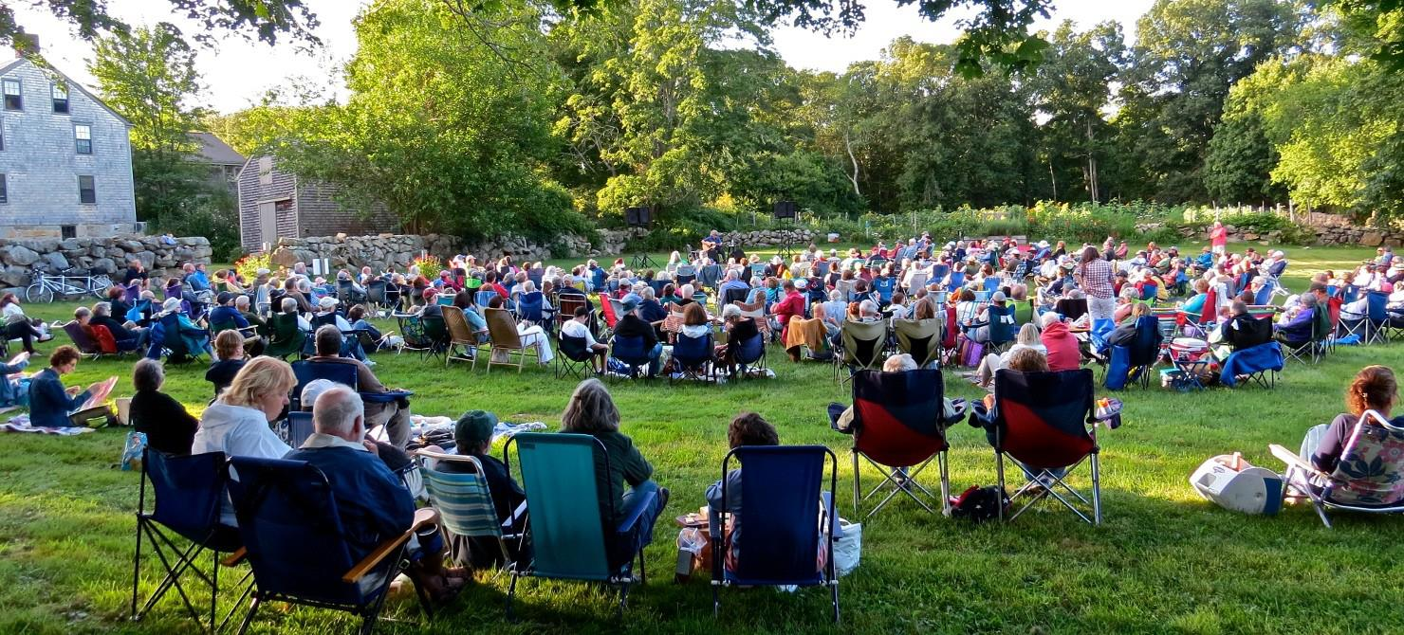

WESTPORT – Save the date! On Saturday, August 4th Westport Land Conservation Trust (WLCT) are pleased to host the 11th annual Town Farm Summer Concert. The goal of the concert is to get Westport residents and non-residents outside and on the land at Westport Town Farm (830 Drift Road) to support the work of the Westport Land Conservation Trust; a not for profit corporation that has worked since 1972 to acquire and preserve natural resources, farmland, and wildlife areas in Westport for the use and enjoyment of future generations.

This summer, WLCT is proud to present an acoustic performance by Anais Mitchell, with guitarist Michael Chorney. Considered one of the best young American folk musicians, Anais Mitchell, a Vermont and Brooklyn-based singer-songwriter, comes from the world of narrative poetry and balladry. Her 2012 Young Man in America album was described by the UK's Independent as ‘an epic tale of American becoming’ and her 2013 Child Ballads, a collaboration with Jefferson Hamer, won a BBC Radio Two Folk Award for Best Traditional Track.


Mitchell has headlined shows worldwide as well as supporting tours for Bon Iver, Ani Difranco, The Low Anthem, Josh Ritter and Punch Brothers. Her stage production of Hadestown, which was ten years in the making, opened off-Broadway in May 2016 to rave reviews. The New York Times called it "inventive, beguiling and spellbinding" while Vogue announced that "Hadestown will be your new theater obsession". The show was extended twice as a result of critical success and will transfer to Broadway for a 2019 opening next year.

“We are extremely excited to host this critically acclaimed musician and artist,” said WLCT outreach coordinator Brendan Buckless. “By bringing Anais Mitchell to Westport Town Farm, we hope to welcome young adults and families onto the land while staying true to the traditional folk music genre that supporters of this concert have come to know and love.”

The outdoor concert starts at 5:30 pm but make sure to arrive early for good seating. Tickets are $20 per person and go on sale at 5 pm at Westport Town Farm (830 Drift Road). Children 12 and under may attend for free.

This concert is supported, in part, by the Westport Cultural Council through a grant from the Helen E. Ellis Charitable Trust administered by Bank of America; Partner’s Village Store & Kitchen; Adamsville Wine & Spirits; and Country Woolens, Westport’s Outdoor Store.

About the Westport Land Conservation Trust
Since its founding in 1972, the Westport Land Conservation Trust has assisted landowners in protecting more than 4,500 acres in Westport, Massachusetts. WLCT is a private non-governmental organization dedicated to local land conservation on behalf of the Westport community. The organization accepts gifts of land and conservation restrictions on land, and assists farm owners in preserving farmland with agricultural preservation restrictions.

