**FOR IMMEDIATE RELEASE -- June 4, 2018**

For further information, contact:

Brendan Buckless

Westport Land Conservation Trust

830 Drift Road, Westport, MA 02790

Tel: 508.636.9228

Email: brendan@westportlandtrust.org

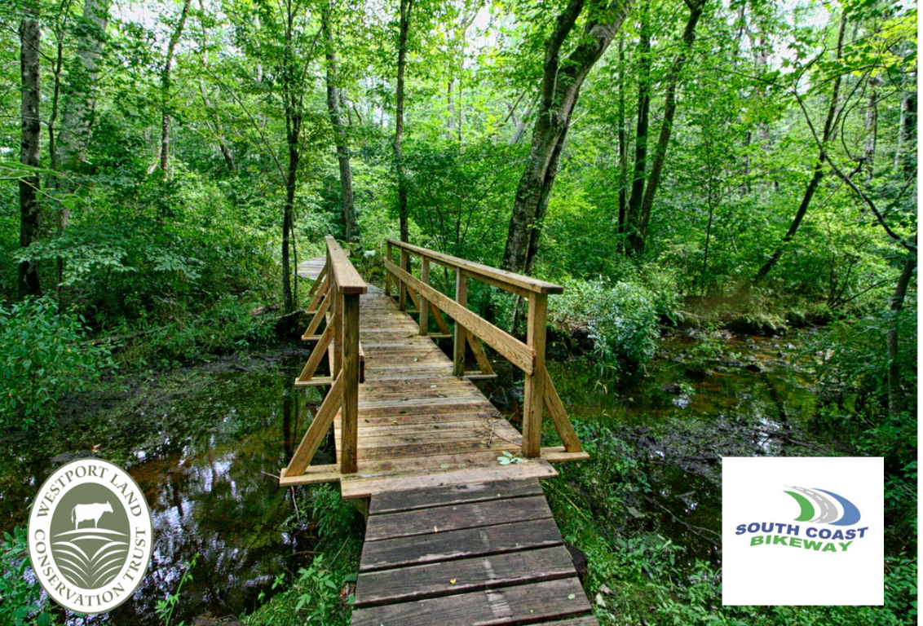

**Westport Land Conservation Trust and South Coast Bikeway Alliance Partner to host Footbridge Building Workshop**

On Friday, June 22nd and Saturday, June 23rd the Westport Land Conservation Trust (WLCT), Westport Bike & Walking Path Committee, and South Coast Bikeway Alliance (SCBWA) are teaming up to host a “Wetland Crossing Workshop” at WLCT’s Dunham’s Brook Conservation Area located at 1520 Main Road in Westport. The workshop will cover the ins and outs of permitting, designing and building footbridges for pedestrian traffic over streams, wetlands and waterways.

Participants will take part in the hands-on construction of two 12-foot wooden footbridges over Dunham’s Brook—one of the largest freshwater tributaries to the west branch of the Westport River. The footbridges will serve as the main pedestrian access trail to over two miles of hiking trails at the 159-acre Dunham’s Brook Conservation Area.

“WLCT is very excited to partner with the Town and with South Coast Bikeway Alliance to improve the robust trail system at Dunham’s Brook Conservation Area,” said WLCT’s executive director Ross Moran. “We hope this project encourages hikers to explore the trails and get inspired by the beauty of Dunham’s Brook Conservation Area!”

The workshop is made possible by the Massachusetts Department of Conservation and Recreation’s competitive recreational trails grant program. With this grant funding, SCBWA and WLCT in partnership with the Town’s bike & walking path committee have retained professional trail builder Peter S. Jensen & Associates, LLC to lead the two-day instructional workshop.

“This funding allows members of the public to complete the workshop free of charge,” said SCBWA president Bob Espindola. “The workshop is a great opportunity for hobbyists and for those interested in professional development.”

Advance registration is required for the workshop. To register, please email Brendan@WestportLandTrust.org. Space is limited to 10 participants.

###

About the Westport Land Conservation Trust

Since its founding in 1972, the Westport Land Conservation Trust has assisted landowners in protecting more than 4,500 acres in Westport, Massachusetts. WLCT is a private non-governmental organization dedicated to local land conservation on behalf of the Westport community. The organization accepts gifts of land and conservation restrictions on land, and assists farm owners in preserving farmland with agricultural preservation restrictions.