Press Release

April 18, 2018

For Release: IMMEDIATE
Contact: Brendan Buckless, Outreach and Stewardship Coordinator
brendan@westportlandtrust.org
Westport Land Conservation Trust
 days: (508) 636-9228

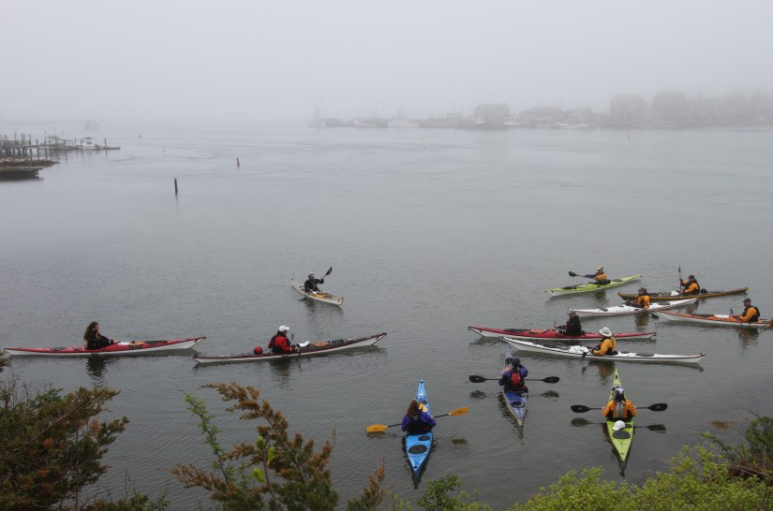
Photo credit: EverythingWestport.com

Cold Water Paddle to Westport Harbor
Westport, Massachusetts – Search for seabirds on a guided cold water paddle tour of Westport Harbor hosted by Westport Land Conservation Trust (WLCT) and Osprey Sea & Surf Adventures. Begin at Westport’s iconic Point of Rocks and cross the Devil’s Pocket to Bial Point. Learn about Westport’s coastal wildlife and WLCT’s efforts to promote wildlife conservation. Paddling-suits, kayaks & equipment will be provided by Osprey Sea & Surf Adventures.
This cold water expedition will run 3 hours and cost $60.00 per participant with a limit of six participants. Participants will meet at Osprey Sea & Surf Adventures located at the Head of Westport on the morning of Saturday, April 28th. Paddlers will be outfitted with equipment and transported to the put-in location.

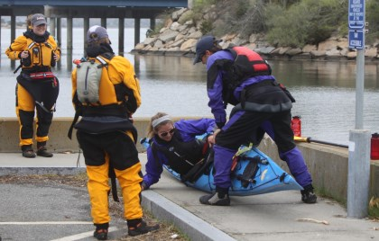
Photo credit: EverythingWestport.com

To register, participants will need to provide their name, phone number, email, approximate height & weight and paddling experience to Westport Land Conservation Trust. You must have previous paddling experience to join this trip. Each participant should have a bottle of water and be dressed in non-cotton based clothing. Water shoes are recommended. For more information or to register, please visit: www.WestportLandTrust.org or call (508)-636-9228 ext. 5023.

About the Westport Land Conservation Trust
Since its founding in 1972, the Westport Land Conservation Trust has assisted landowners in protecting more than 4,500 acres in Westport, Massachusetts. WLCT is a private non-governmental organization dedicated to local land conservation on behalf of the Westport community. The organization accepts gifts of land and conservation restrictions on land, and assists farm owners in preserving farmland with agricultural preservation restrictions.

