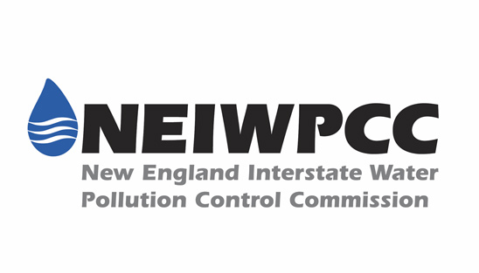

**Environmental Analyst – Bioextraction Coordinator**

**Long Island Sound Study**

*Stony Brook, New York*

**Organizational Background:** The New England Interstate Water Pollution Control Commission (NEIWPCC) is a not-for-profit, 501(c)(3) organization, established in 1947 by an Act of the United States Congress. NEIWPCC serves its member states—Connecticut, Massachusetts, Rhode Island, New York, New Hampshire, Vermont, and Maine—by coordinating efforts that encourage cooperation among the states, developing resources that foster progress on water issues, representing the region in matters of federal policy, training environmental professionals, managing programs, administrating grants, initiating and overseeing scientific research, educating the public, and providing overall leadership in water management and protection. NEIWPCC's primary mission is to integrate the states’ individual efforts to maintain and improve water quality in the Northeast.

**Long Island Sound Study**: The LISS is part of the National Estuary Program established by the 1987 amendments to the Clean Water Act (Section 320). The LISS is sponsored by the U.S. Environmental Protection Agency (EPA) and the states of Connecticut and New York and involves other participants through a cooperative Management Conference. A Comprehensive Conservation and Management Plan (CCMP) for protecting and improving the health of Long Island Sound while ensuring compatible human uses within the Sound ecosystem was renewed in 2015.

**Position Announcement:**

NEIWPCC is seeking an Environmental Analyst to provide overall program coordination, administration, and short and long-term planning for the bioextraction program of the Long Island Sound Study (LISS) including: assess potential challenges to, identify solutions for, and support the development and expansion of nitrogen bioextraction and related aquaculture activities in the Long Island Sound (LIS). Specific duties include ecological and cultivation research and reporting; development of siting tool and collection of site identification data; permitting for new and expanding aquaculture operations; environmental assessments of bioextraction and bioharvesting projects; and messaging and outreach.

The successful candidate will have a master’s degree in the natural sciences (biology, chemistry, ecology, environmental science, etc.). Course work and/or demonstrated proficiency in marine ecology, fisheries management, aquatic and terrestrial biology, and GIS analysis strongly preferred. Excellent communication, organization, and computer skills required. Ability to use and master ArcGIS required.

Refer to [www.neiwpcc.org](http://www.neiwpcc.org) for full position description. To apply, submit cover letter, resume, and a brief writing sample by November 10, 2017 to [jobs@neiwpcc.org](mailto:jobs@neiwpcc.org). In the email subject line, please reference position number 18-LISS-001.