October 5, 2017
FOR IMMEDIATE RELEASE
Contact: Stephanie Ellis, Executive Director, WILD CARE Inc.
Phone: (650) 319-5491 cell, Stephanie@wildcarecapecod.org

###
HARVEST “DINE-OUT” EVENT AT VAN RENSSELAER’S – TO BENEFIT WILD CARE

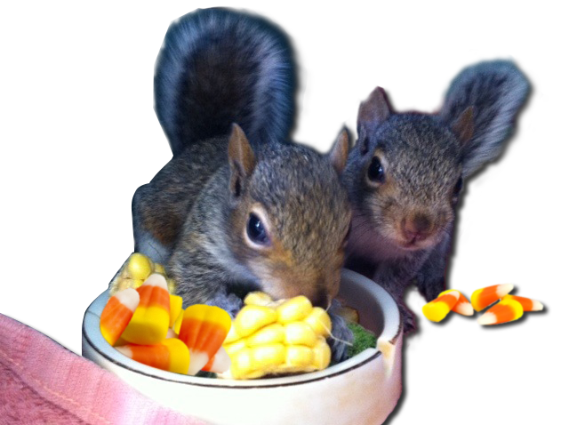
Eastham. On Thursday, October 19th, from 4 PM- 8:30 PM, Van Rensselaer’s (VR’s) Restaurant in S. Wellfleet will host a Harvest “Dine-Out” Dinner to support Wild Care. Between 4 PM and 8:30 PM, order anything off the regular menu, and a portion of the proceeds will be donated to Wild Care. In addition, Van Rensselaer’s is offering a special 3-Course “Prix Fixe” menu, with vegan and vegetarian selections. Pricing for the Prix Fixe is $40, or $50 with wine pairings. Generously, 100% of the proceeds from the Prix Fixe menu go to Wild Care! (Check Wild Care’s website at www.wildcarecapecod.org for the upcoming menu.) “VR’s owners Diane and Peter Hall have been incredibly generous to Wild Care,” states Wild Care Executive Director, Stephanie Ellis. “Since 2012, VR’s has hosted a special annual dinner in our honor. I can’t think of a more wonderful opportunity to celebrate the season and support Wild Care. The chefs at VR’s are incredibly talented, and patrons are in for an exquisite dinner and evening. This year, we are also bringing special guests. Our Educational Eastern Screech Owl,
“Up Up”, and “#45” the Eastern Box Turtle, will be there from 5-7 PM to greet guests.” This fundraiser will help Wild Care continue its mission of providing personalized care for injured wildlife, and raising awareness about the impacts wildlife are facing on Cape Cod.

Wild Care invites the public to dine out at Van Rensselaer’s on October 19th, and support this wonderful restaurant and great cause! The evening’s activities will also include a “Blind Bid” Auction. You do not have to be present to win.

Van Rensselaer’s is located at 1019 Rt. 6 S. Wellfleet. http://vanrensselaers.com

RSVP is strongly encouraged. To RSVP, contact VR’s at 508-349-2127. For general information about this event, contact Stephanie@wildcarecapecod.org. Details on our website at www.wildcarecapecod.org, and also on Facebook under “Events”. https://www.facebook.com/WildCareCapeCod/

WILD CARE’s wildlife rehabilitators treat birds, mammals and reptiles brought to the center, with the goal of releasing them back into the wild when they are capable of independent survival. Through public education, WILD CARE works to prevent wildlife casualties and works to engage the community in conservation through volunteerism. Since our founding WILD CARE has accepted over 22,000 wild creatures, representing over 275 species of native birds, mammals & reptiles.
###

