Press Release

February 16, 2017

For Release: IMMEDIATE
Contact: Brendan Buckless, Outreach and Stewardship Coordinator
brendan@westportlandtrust.org
 days: (508) 636-9228

Wild Winter Lecture Series: The Global Carbon Budget
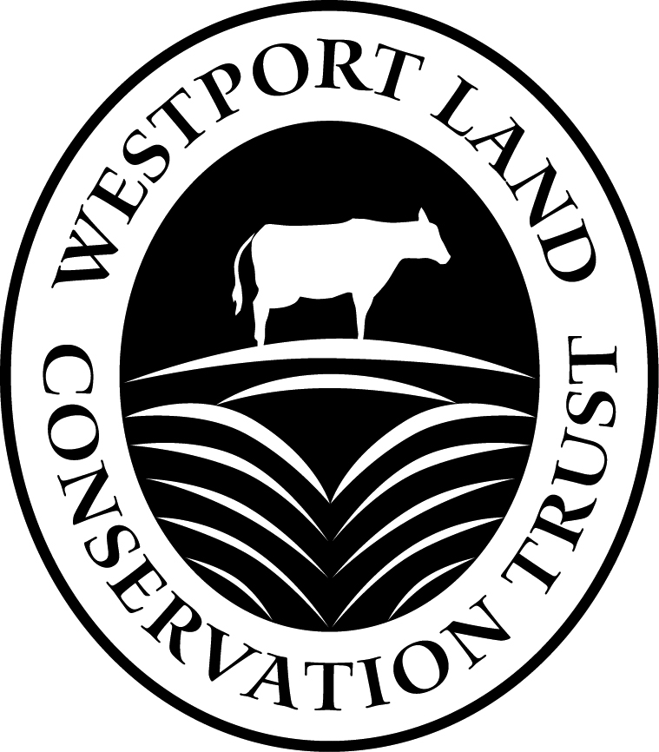
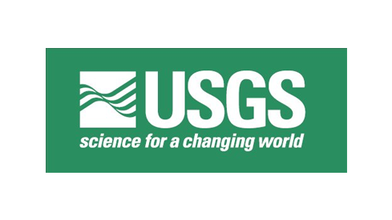

Westport, Massachusetts – Join Westport Land Conservation Trust and U.S. Geological Survey Research Geologist, Erik T. Sundquist, for the third installment in our annual Wild Winter Lecture Series at the Westport Free Public Library (408 Old County Road). How are modern scientists tackling the problem of never-before-seen levels of carbon dioxide in the atmosphere? Learn about efforts to mediate atmospheric carbon dioxide through research on carbon sequestration. The lecture will begin promptly at 6 PM this Thursday, February 23, 2017. For more information or to RSVP for this event, please contact Brendan@WestportLandTrust.org.

About the Westport Land Conservation Trust

Since its founding in 1972, the Westport Land Conservation Trust has assisted landowners in protecting more than 4,000 acres in Westport, Massachusetts. WLCT is a private non-governmental organization dedicated to local land conservation on behalf of the Westport community. The organization accepts gifts of land and conservation restrictions on land, and assists farm owners in preserving farmland with agricultural preservation restrictions.

