Press Release

March 4, 2016

For Release: IMMEDIATE
Contact: Brendan Buckless, Outreach and Stewardship Coordinator
brendan@westportlandtrust.org

Ryan Mann, Executive Director
Westport Land Conservation Trust
 days: (508) 636-9228

Eyes on Owls: A Live Owl Show
Westport, Massachusetts –
Who’s watching you? Find out on Saturday, March 19th, when Eyes On Owls, a Live Owl Show is presented by the Westport Land Conservation Trust at the Westport High School Auditorium, 19 Main Road, Westport MA. All who attend are in for some fun with educational close-up views of these secretive birds of prey. Naturalists Mark and Marcia Wilson will present “Who’s Watching You? Owls of the World.” Two shows will be offered this year at 10am and 1pm.

The Wilsons introduce the audience to owls found in New England and other parts of the world. A slide show begins the program by showcasing colorful wildlife photos by her husband Mark Wilson. Marcia imitates the owls’ calls herself, paying special attention to the more common owls that we might encounter in our area.

After a hooting lesson and much audience anticipation, Marcia brings out the live owls one at a time. With each owl perched securely on her gloved hand, she walks out among the audience. There’s plenty of time for close-up views, photos and questions.

Each owl presented has a permanent disability which prevents him or her from surviving on their own in the wild. These non-releasable owls serve as captivating ambassadors from the world of wildlife. All the owls are legally permitted by state and federal agencies for use in environmental educational programs.

Which owl eats skunks? Can a little detective work reveal where owls live near you? What do pellets tell us about an owl’s diet, the food chain and the web of life? How can we protect owls and their habitats? Wilson explores these questions and more during this fun, interactive program.

Tickets are $10 for adults, $5 for children 12 and under (not recommended for children under age 5) and available for purchase online at www.westportlandtrust.org. Tickets will also be sold at the door on the day of the event.
This program is supported in part by a grant from the Westport Cultural Council, a local agency which is supported by the Massachusetts Cultural Council, a state agency. This event is made possible by generous sponsorships from: Whaling City Transit, Country Woolens, Anchor Animal Hospital, Even Keel Realty, Westport Law, and Source One IT.

Photographs:
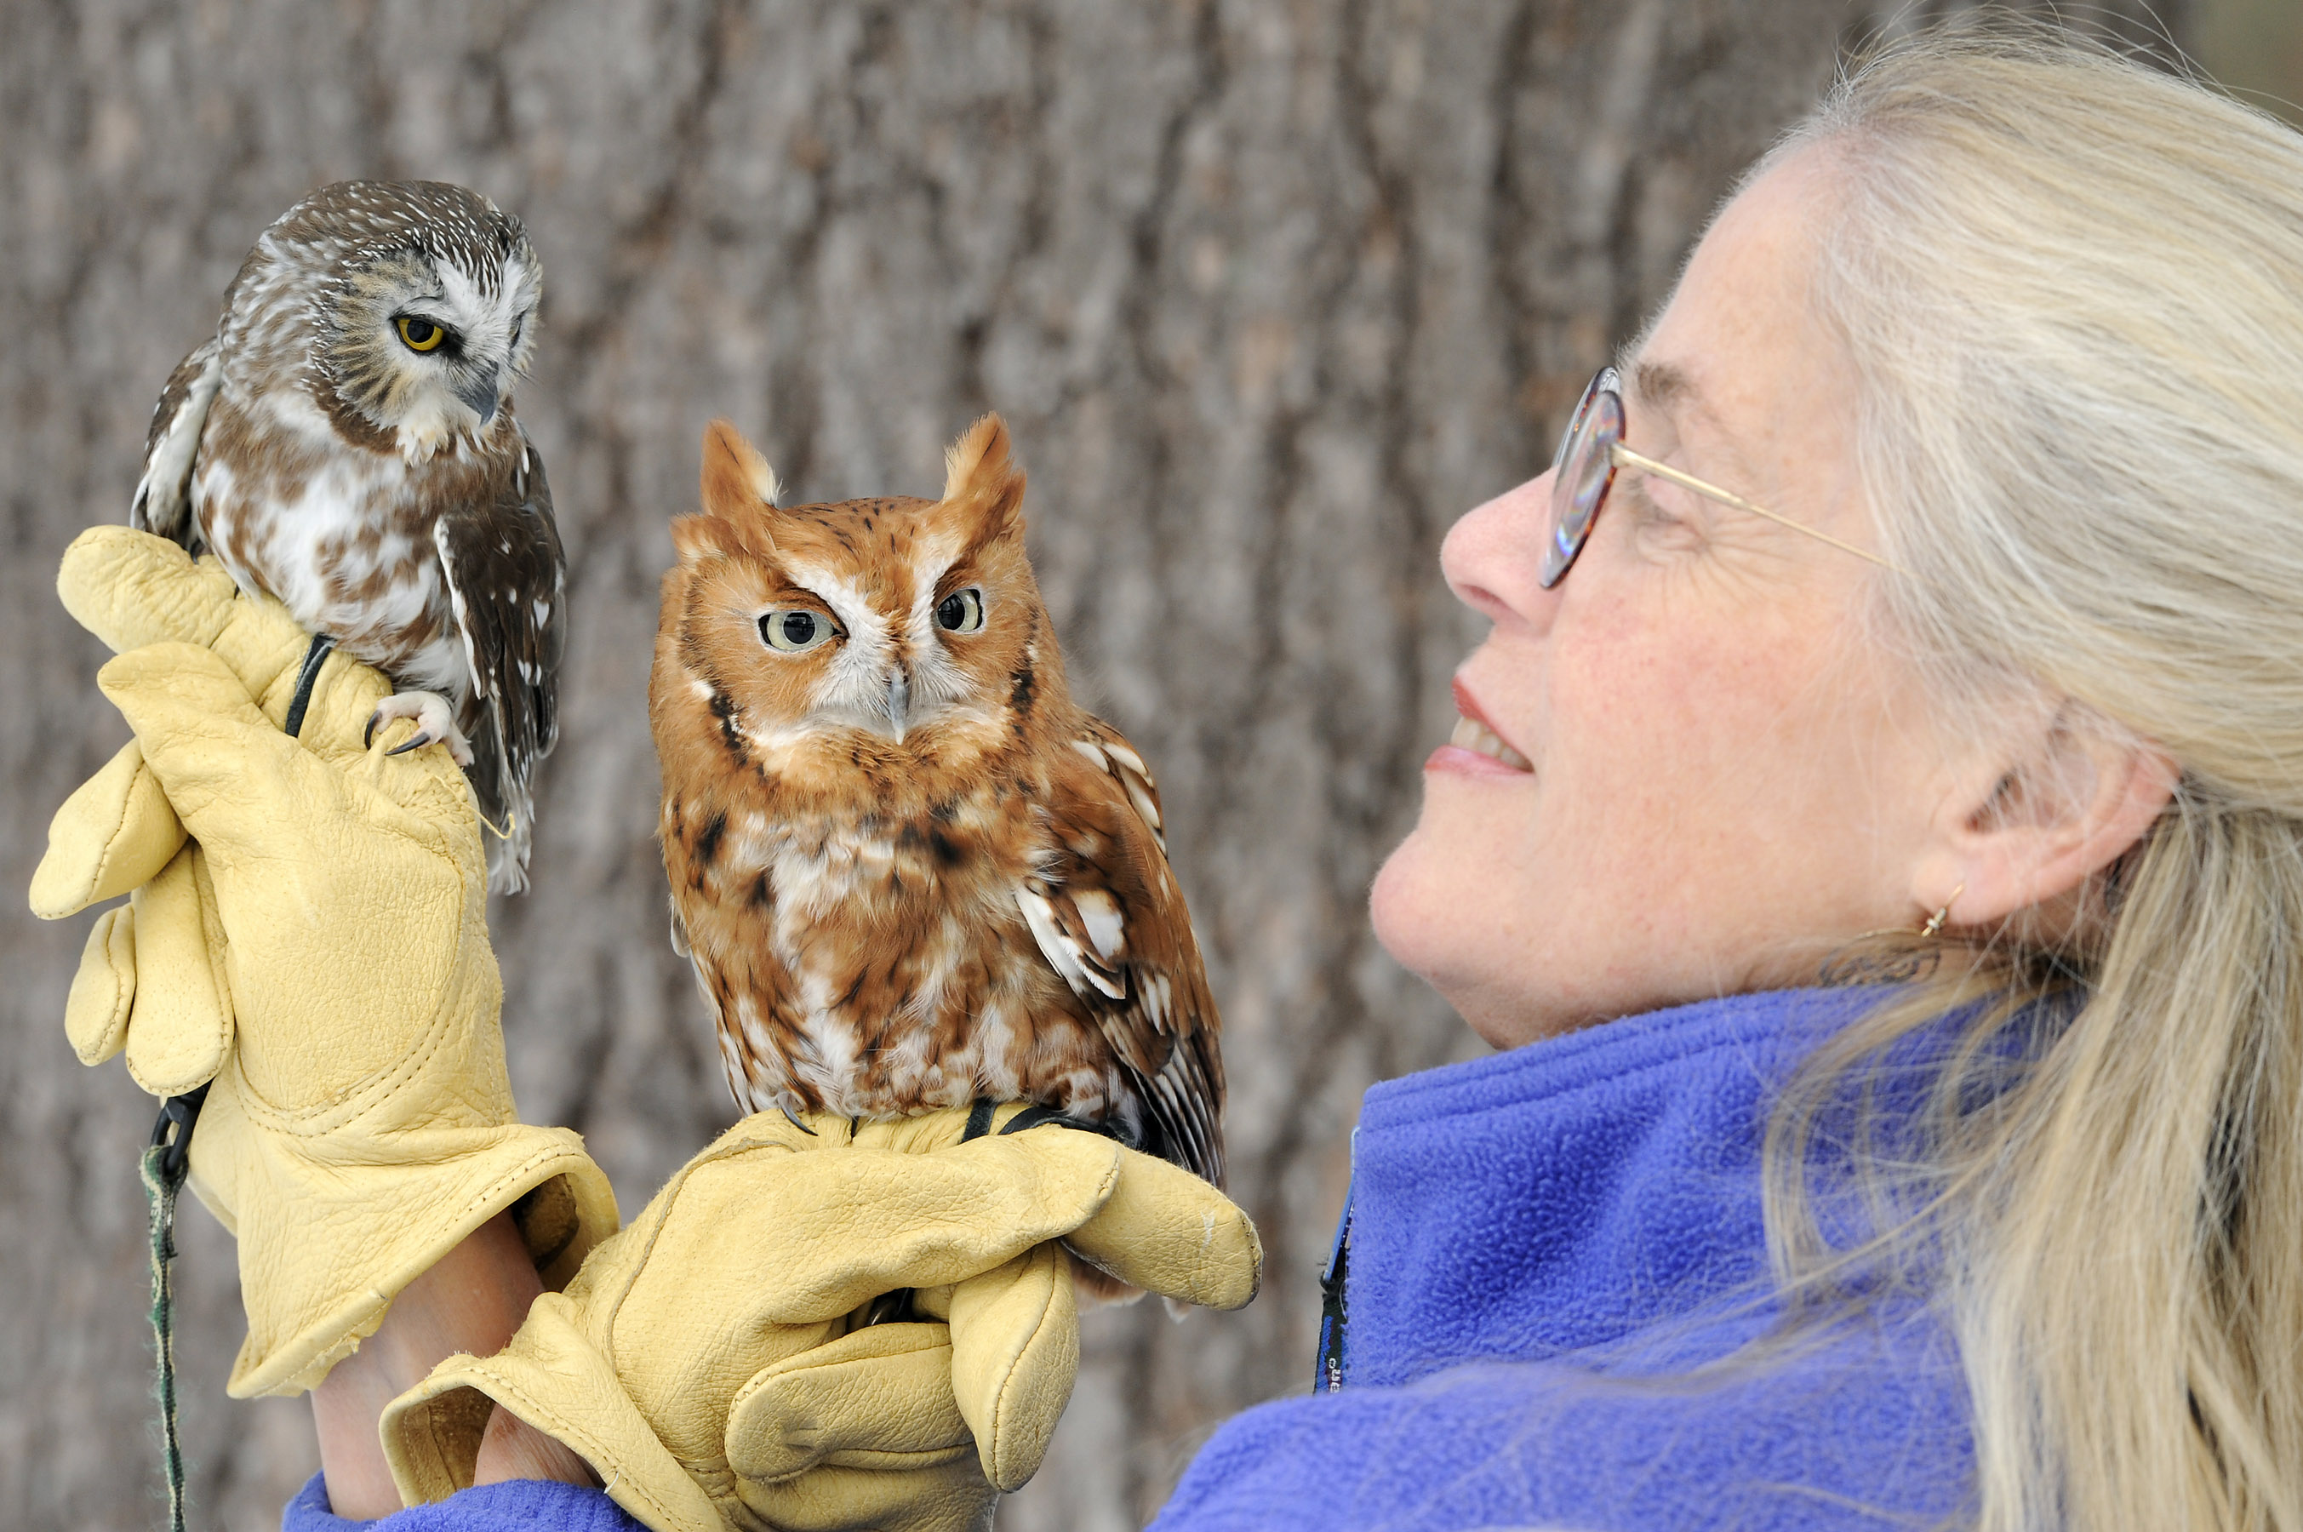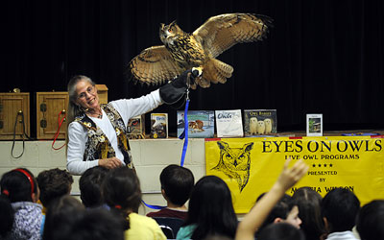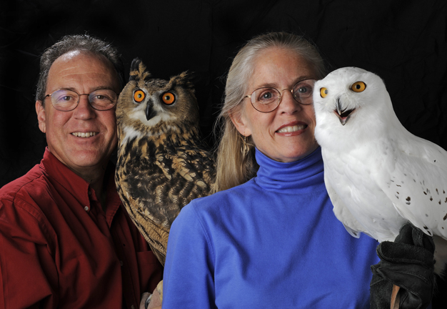

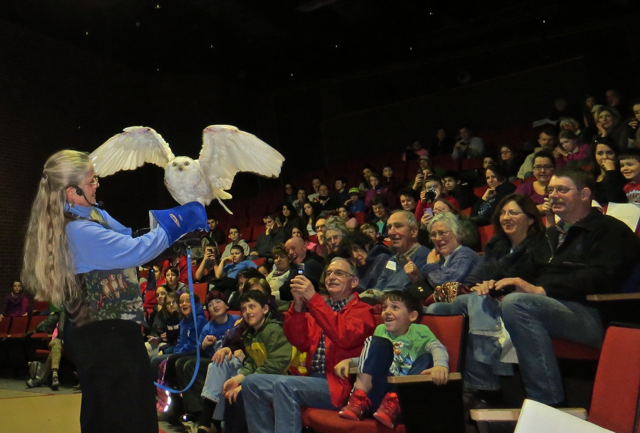

About the Westport Land Conservation Trust
Since its founding in 1972, the Westport Land Conservation Trust has assisted landowners in protecting more than 1,756 acres in Westport, Massachusetts. WLCT is a private non-governmental organization dedicated to local land conservation on behalf of the Westport community. The organization accepts gifts of land and conservation restrictions on land, and assists farm owners in preserving farmland with agricultural preservation restrictions.

