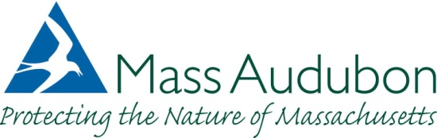

FOR IMMEDIATE RELEASE CONTACT: Laura Hearn or
May 4, 2015 Suzan Bellincampi
508-627-4850

BIRD-A-THON 2015: 32 YEARS & COUNTING – BIRDING TO RAISE FUNDS FOR
FELIX NECK WILDLIFE SANCTUARY

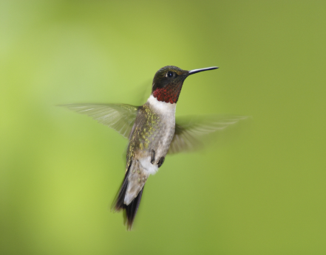
edgartown, Mass.— Felix Neck needs birders and sponsors to participate in Mass Audubon’s 32nd year of birding competition. Birders and donors raise money for Felix Neck Wildlife sanctuary and our programs by getting pledges per number of bird species seen or making a donation to the Felix Neck team.

Started in 1983, the statewide Bird-a-thon has grown to 29 teams and more than 800 staff and volunteers who help raise thousands of dollars to benefit Mass Audubon’s efforts to protect wildlife. The 24-hour competition starts at 6 p.m. on Friday, May 15, and runs through 6 p.m. on Saturday, May 16. But you don’t have to participate the entire time—rotating shifts among teammates is encouraged! The 24-hour timetable allows flexibility in schedules and the chance to locate nocturnal birds.

Mass Audubon will award numerous prizes, including trophies to three teams in the following categories: most money raised, most species recorded, and largest percentage increase of money raised (from the previous year). Team members who raise a minimum of $100, or obtain 10 sponsor pledges, will receive a 2015 Mass Audubon Bird-a-thon T-shirt.

Even if you can’t join a team, you can still participate by pledging money to a team member for each bird species recorded during the 24-hour event. If 20 people collected 10 pledges, each at 10 cents a species, and if the sanctuary sees 200 species, the sanctuary raises $4,000—to help protect wildlife on Martha’s Vineyard. To join a team, make a pledge or donation, or find out more, contact Felix Neck at 508 627-4850 or visit www.massaudubon.org/birdathon.

Mass Audubon works to protect the nature of Massachusetts for people and wildlife. Together with more than 100,000 members, we care for 35,000 acres of conservation land, provide school, camp, and other educational programs for 225,000 children and adults annually, and advocate for sound environmental policies at local, state, and federal levels. Founded in 1896 by two inspirational women who were committed to the protection of birds, Mass Audubon is now one of the largest and most prominent conservation organizations in New England. Today we are respected for our sound science, successful advocacy, and innovative approaches to connecting people and nature. Each year, our statewide network of wildlife sanctuaries welcomes nearly half a million visitors of all ages, abilities, and backgrounds and serves as the base for our work. To support these important efforts, call 800-AUDUBON (800-283-8266) or visit www.massaudubon.org.

