
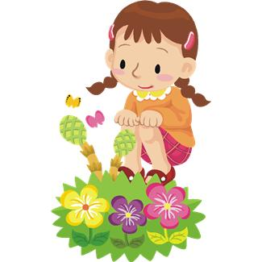
April School Vacation Activities
Waquoit Bay National Estuarine Research Reserve
INTERPRETIVE PROGRAM

131 Waquoit Highway (Route 28), Waquoit, MA
(508) 457-0495 www.waquoitbayreserve.org

StoryWalk™ – The Seaside Switch
Available Tuesday through Friday 9:00AM to 5:00PM

Hike the trail outside the Visitor Center and follow the story, The Seaside Switch by Kathleen v. Kudlinski. Along the way you’ll discover the sea and sand creatures whose lives revolve around the ebb and flow of the sea and the young boy who stops to investigate the wonders he finds at water’s edge. (This self-guided outdoor activity was first created by Kellogg-Hubbard Library and the Vermont Bicycle & Pedestrian Coalition.)

How Does Your Garden Grow?
Tuesday, April 22 10:00AM -11:30AM

Celebrate the earth and discover both living and non-living elements that help a garden to grow. We will play an active food chain game, discover critters in the compost and explore animal and plant adaptations with a Pollinator Pairs match-up activity. After a visit to the Reserve’s rain, vegetable and pollinator gardens you’ll have a chance to make a compostable pot and plant some seeds to take home.

Raptors Revealed
Wednesday April 23, 10:00AM-11:30AM

Games and activities help us examine the lives of birds of prey and learn about specialized features that help them to hunt and find food. Learn where snowy owls and osprey go in different seasons and why vultures have bald heads. Use your CSI skills to examine an owl pellet to discover the bird’s last meal. We’ll spy on nests near the visitor center and discover where you can watch osprey inside their nests, as the eggs hatch and chicks learn to fly.

Program is free and open to the public. Reasonable accommodations available upon request. For more information, call (508) 457-0495. For park information www.mass.gov/dcr/parks/southeast/wbnr.htm
Spring 2014

