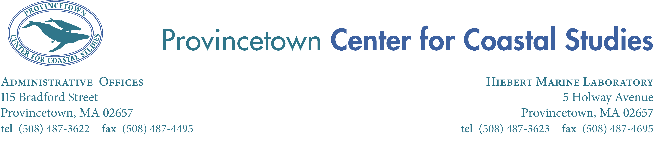

Summer 2014 Internship Opportunity

The Center for Coastal Studies is a non-profit organization dedicated to conducting scientific research with emphasis on marine mammals of the western North Atlantic and on the coastal and marine habitats and resources of the Gulf of Maine. CCS has been conducting research and marine and coastal educational programs on Cape Cod for over 37 years.

Education Responsibilities-Intern will assist with environmental education programs, including on-site programs, off-site programs, marine debris research project and festivals, including CCS’s new signature summer week of events: Whale Week: A Celebration of the Sea. Interns will assist in the staffing of the Center’s informational and sales kiosk on MacMillian Pier; designing and delivering presentations, answering questions about CCS, marine mammals and ocean conservation issues, and other general duties. Intern may assist with creation of displays for the CCS’s laboratory, and help create lesson plans and activities that are aligned with the Massachusetts State Frameworks.

Other Responsibilities- Each intern will take on a project which they will work on for the duration of their internship.

Interns must have their own transportation, and housing is not provided. A small stipend is provided.

Qualifications-
- The internship is open to students who are currently enrolled in, or recently graduated from an accredited college or university. High school students may also be considered.
- Preference will be given to students or recent graduates working towards environmental studies, education, marine science, biology or other related fields.
- Intern should demonstrate strong written and verbal communication skills.
- Intern should be a self-starter able to take responsibility for completing projects.
- Students that are adaptable, responsible, hard working, willing to learn, and have attention to detail are encouraged to apply.
- Must be able to work independently and as part of a team.
- Must be comfortable working with all ages.
- Must be comfortable working outside in all conditions.
- Must be comfortable working with and handling marine species.
- Interns must be able to commit to at least two-three months; preferred start date-end date beginning June to mid August, but dates are flexible based on school schedules.
- Interns must work a minimum of 20 hours per week.
- Schedule is flexible but intern may have to work some weekends and evenings.
- Preference will be given to students with secured housing on Cape Cod.

To Apply- Send your resume, cover letter, and one letter of reference to Laura Ludwig at lludwig@coastalstudies.org or 115 Bradford St, Provincetown, Massachusetts 02567. Applications must be received by April 4th, 2014.

