Massachusetts Bays Program
251 Causeway Street, Suite 800, Boston, MA 02114
(617) 626-1230 / Fax (617) 626-1240
www.massbays.org
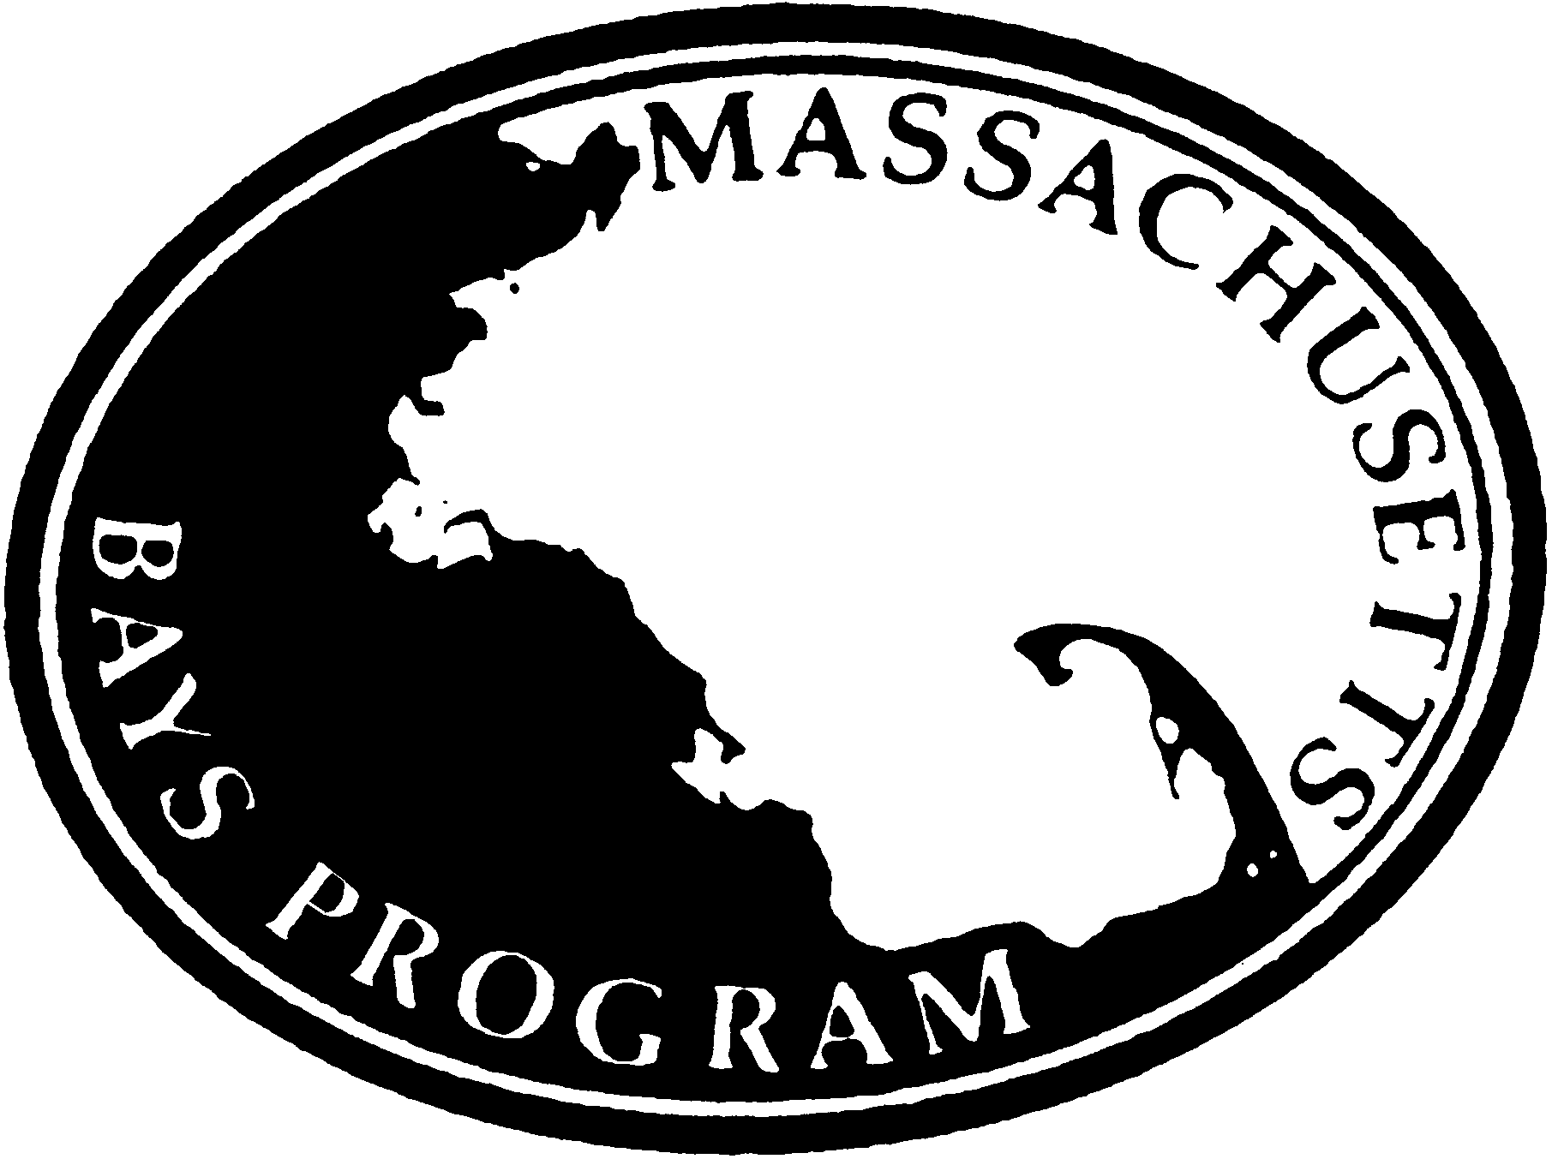

The Massachusetts Bays Program Announces Availability of Funding Through its Research and Planning Grant Program

October 16, 2013

The Massachusetts Bays National Estuary Program (Mass Bays) is pleased to announce the availability of up to $100,000 in total funding through the Mass Bays Research and Planning Grant Program. Through this grant program, Mass Bays will provide individual grants of up to $20,000 for initiatives located within 50 coastal communities from Salisbury to Provincetown for mission-based initiatives along Massachusetts and Cape Cod Bays.

Hosted by the Massachusetts Office of Coastal Zone Management (CZM), the Massachusetts Bays Program is an EPA National Estuary Program dedicated to protecting, restoring, and enhancing the estuarine ecosystems of Massachusetts and Cape Cod Bays. We facilitate partnerships to prompt local, state, and federal action and stewardship; convene stakeholders on the local and regional level; and provide scientific bases and technical support for decision making that addresses problems with sustainable solutions. Eligible projects include research and planning initiatives that advance Mass Bays’ priorities, which focus on protecting, restoring, and enhancing coastal habitats, including shellfish and sea grass beds, salt marshes, and beaches, especially identifying and responding to projected impacts of climate change and sea level rise on those habitats.

Eligible applicants include Massachusetts cities, towns, and other public entities, academic institutions, and certified 501(c)(3) non-profit organizations. Project proponents must provide a minimum of 25% match of the total project cost (cash and/or in-kind).

Applications are due on Friday, November 22, 2013. All projects must be completed by December 31, 2014. To view the Request for Responses (RFR), visit www.comm-pass.com, solicitation number ENV 14 CZM 04. Two informational conference calls will be held prior to the submission deadline. For more information on the Mass Bays program, its partner communities and organizations, and projects previously funded through this grant program, visit www.massbays.org. For questions about the RFR, please contact:

Prassede Vella
Massachusetts Bays Program
251 Causeway Street, Suite 800
Boston, MA 02114
Phone: 617-626-1217
Email: Prassede.Vella@state.ma.us

