
-SEA LEVEL RISE
-CLIMATE JUSTICE
-PUT CLIMATE PROFITEERS ON NOTICE

Stand Out and Help Draw the Line
Saturday, September 21
10 -11 AM
Falmouth Village Green

Stand out and help draw the line on sea level rise. Redirect investments in dirty energy plants to clean, renewable, locally produced energy, conservation and efficiency.

Draw attention to Bank of America's financing of tar sands extraction and the coal industry. In 2012, BOA ranked in the top 5 coal financiers, and in the top 10 tar sands financiers since 2007, according to the Rainforest Action Network. By lending money to this industry, this bank and others are betting on the success of extractive industry. They enable the dirty energy business to continue and reap profits from it.

Draw the line to redirect hundreds of billion dollars the United States invests in coal, oil, nuclear and gas into research and development of sustainable energy alternatives. Draw the line to shut down Brayton Point coal-fired plant, Pilgrim Nuclear Power Station, and stop the endless wars.

America is slashing oil use – now we need more innovation, more efficiency, and more transportation choices to build a fair and equitable, sustainable and prosperous clean energy economy.

Materials and visuals: Please bring your most colorful plastic bags to tie together to make rope lines; carry banners, posters and placards. We will have info posters on sea level rise maps of Cape Cod, and Falmouth.
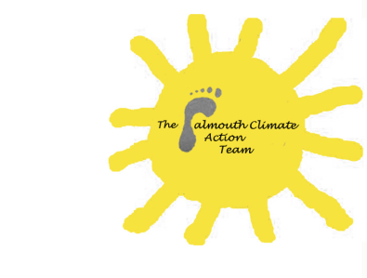
Coordinated by Falmouth Climate Action
For further information contact
fcat2012@aol.com or call 508-566-5988


