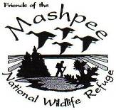

Cape Cod Osprey Project
Waquoit Bay National Estuarine Research Reserve

149 Waquoit Highway (Route 28), Waquoit, MA
(508) 457-0495 –www.waquoitbayreserve.org

Mark Faherty, Science Coordinator, MAS Wellfleet Bay Sanctuary
Saturday, March 23rd, 2:00pm
Nate Goshgarian photo

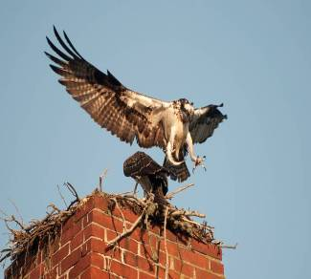
Mark Faherty, Science Coordinator for Mass Audubon’s Wellfleet Bay Sanctuary, oversees a number of research projects involving citizen scientists, including the Osprey Project which is documenting the resurgence of the species on Cape Cod. Mark provides insights into his research using data from volunteers monitoring osprey nests across the cape, including more than 30 around Waquoit Bay. Mark will report his finding on nesting success in our region and will include migration data obtained from satellite tagged birds that traveled to South America for the winter.

Meet at Reserve Visitor Center, 149 Waquoit Highway (Rt.28), Waquoit, MA. Reasonable accommodations are available upon request. Co-sponsored by the Friends of Mashpee National Wildlife Refuge. For all ages; $5 donation to Friends Group. For information, call (508) 457-0495. For park info visit www.mass.gov/dcr/parks/southeast/wbnr.htm.

department of Conservation and Recreation

