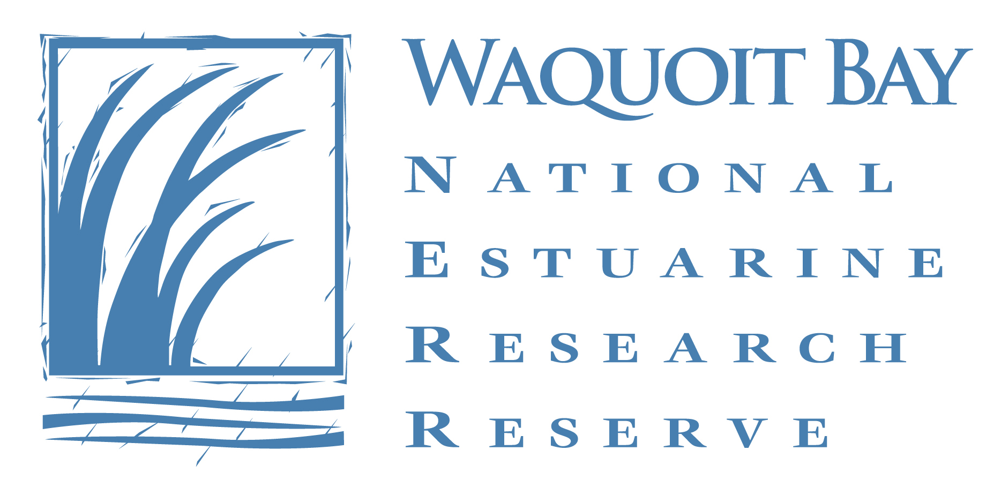

Summer Science Teacher Wanted

Seeking an experienced and enthusiastic educator to co-direct the Waquoit Bay Reserve’s Summer Science School. The program consists of week-long educational experiences for different age levels that encourage curiosity in science and the natural world. Program dates are July 1 through August 16th.

- The successful applicant will work with children in grades 2 through 9, conducting engaging, hands-on activities in the classroom, woodlands, salt marshes and shoreline within the Reserve.
- Schedule - Monday through Friday, usually 8:30 AM to 4:30PM with one overnight camping trip to Washburn Island on August 1st.
- Program requires teaching 7, week-long sessions and attending one week of paid training and planning starting June 24th.
- Must have completed at least 3 years of college in a related field: science, education, conservation, etc.
- Experience working with children as well as outdoor education and field experience. Current CPR/ First Aid certification required.
- Must be knowledgeable about coastal ecology and comfortable working in the field and handling live marine invertebrates.
- Interest and knowledge of renewable energy helpful.

Waquoit Bay Summer Science School is sponsored by the Waquoit Bay Reserve Foundation.

Closing date for this position is March 31, 2013
To apply, please send a cover letter, resume and three references to:
Waquoitsummerschool@gmail.com or

WBRF Summer Science School, PO Box 3522, Waquoit, MA 02536

