
Department of Conservation and Recreation, Massachusetts State Parks

Coming Event
Waquoit Bay Reserve
INTERPRETIVE PROGRAMPRIVATE

149 Waquoit Highway (Route 28)
Waquoit, MA 02556
(508) 457- 0495 ext. 125

Winter Beach Solstice Walk
Friday, December 21 2:00PM – 4:00PM

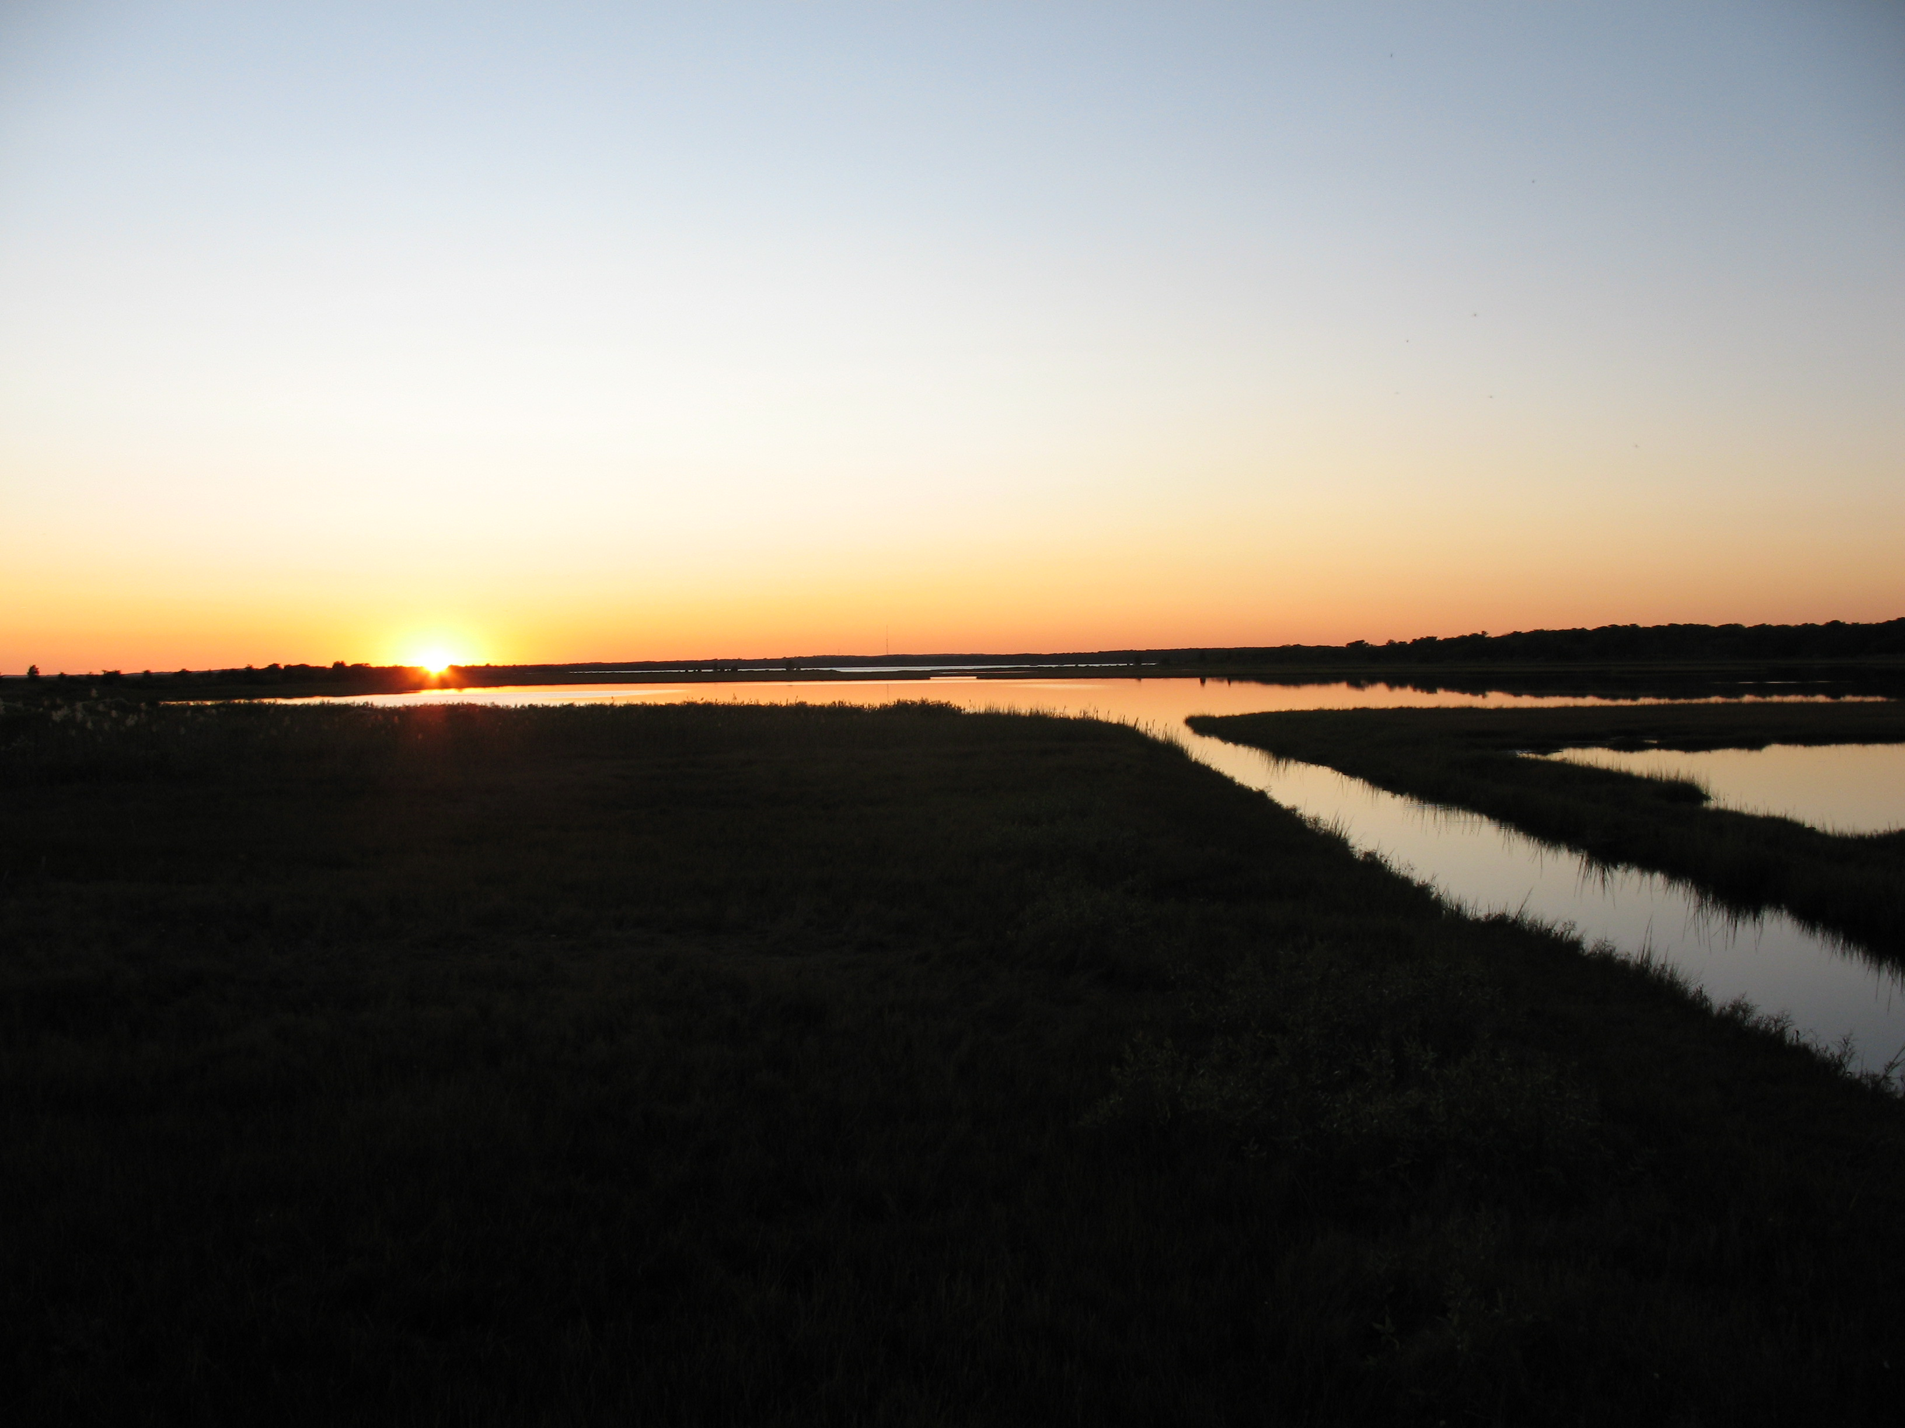
Celebrate the Winter solstice with a brisk coastal walk followed by hot chocolate. Discover seasonal changes to the shoreline and wildlife at South Cape beach as the year’s shortest day comes to a close. Walk up to 2 miles. Please dress for the weather. Rain cancels.

Meet at Mashpee Town Parking Lot at South Cape Beach, Great Oak Road, Mashpee. For more information or to register visit our we website at www.waquoitbayreserve.org or


Call (508) 457 – 0495 (ext. 125) ( Fall 2012)

