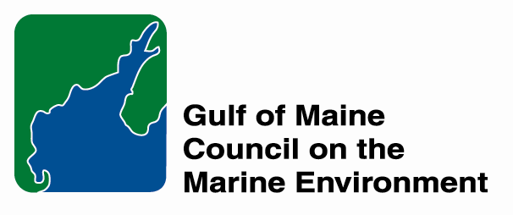

For Immediate Release
20 October 2012

For more information, contact:
Slade Moore
Habitat Restoration Coordinator
Maine Coastal Program and Gulf of Maine Council on the Marine Environment

smoore@bioconserve.net

PRESS RELEASE

GOMC Habitat Restoration Grants Program
Request for Letters of Intent

The Gulf of Maine Council on the Marine Environment (GOMC) has released a request for habitat restoration project Letters of Intent. Projects receiving grants seek to reverse impacts to salt marshes, rivers, streams, shellfish beds, eelgrass, and other key features of ecological, economic and cultural importance in the Gulf of Maine Ecosystem. The projects are selected to offer long-term ecological benefits and promote community-level capacity for restoration. Many projects provide added value by assisting with replacement of aging structures like road culverts or removal of dams that may be a liability to public safety and can represent a financial burden to their owners.

The mission of GOMC is to maintain and enhance environmental quality in the Gulf of Maine to allow for sustainable resource use by present and future generations. Since its establishment in 2002, the GOMC Habitat Restoration Partnership with NOAA has helped support 110 projects with over $3.5 million in restoration funding. Together, these projects re-opened access to 163 miles of rivers and streams for fish like river herring, Atlantic salmon and American eel. In addition, these projects re-established access for spawning alewife to over 2,700 acres of lakes and ponds and rehabilitated over 650 salt marsh acres.

The economic impact of restoration projects is also noteworthy, because each project must provide matching support that is equal to, or exceeds the value of the award amount. Likewise, the engineering and construction needs of projects means that Partnership funding helps support jobs in each project’s home state or province.

The purpose of the Letter of Intent request is to identify funding needs for habitat restoration projects that will significantly advance restoration priorities and aid in the development of funding proposals to support the GOMC Habitat Restoration Grants Program. Letters of Intent will be accepted October 26 - November 23, 2012 via the online submittal process described in the Request for Proposals (RFP), which can be accessed at: http://restoration.gulfofmaine.org/index.php. For more information, contact Slade Moore, the Habitat Restoration Coordinator for GOMC and the Maine Coastal Program, at smoore@bioconserve.net.

***END***

