
Department of Conservation and Recreation, Massachusetts State Parks

Coming Event
Waquoit Bay Reserve
INTERPRETIVE PROGRAMPRIVATE

149 Waquoit Highway (Route 28)
Waquoit, MA 02556
(508) 457- 0495 ext. 125

Nature at Night Full Moon Hike
Thursday, November 10th 6:30 – 8:30PM

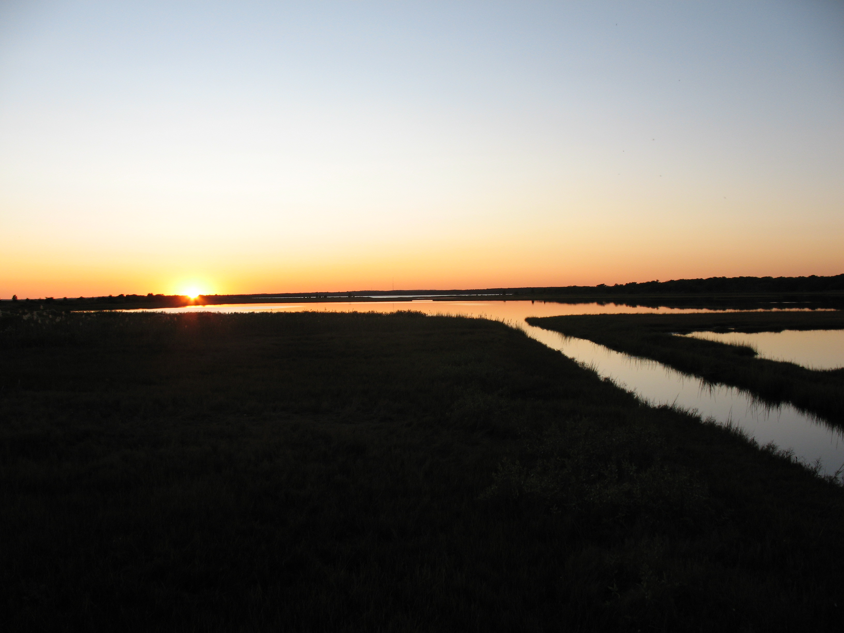
Join a WBNERR naturalist for a nighttime adventure to start off Veteran’s Day weekend. Explore the beach, dunes and bay under the light of the full Beaver Moon. We’ll discover the sights, sounds and smells of nature at night and learn about nocturnal wildlife and the area’s military past along the way. Walk up to 2 miles. Please bring a flashlight. Rain cancels.

Meet at Bayberry Parking Lot just past South Cape Beach State Park Lot on the right.
For more information or to register visit our we website at www.waquoitbayreserve.org or


Call (508) 457 – 0495 (ext. 125)

