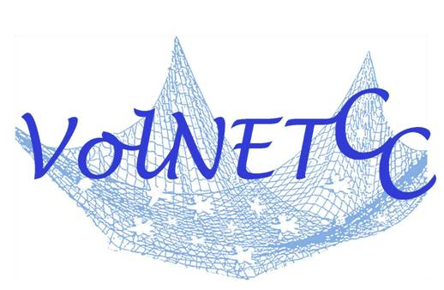
VOLNETCC July Quarterly Program Meeting

Date: Monday, July 20, 2009
Location: Elder Services, 68 Rte 134 South Dennis, MA 02660
Topic: Conflict Resolution
Time: 1:00pm – 3:00pm
1:00 pm Registration and Networking
1:15 pm Presentations

Speakers:
Joy Adams, Cape Cod Mediation Group
Kerrie Constant, Girl Scouts of Southeastern Massachusetts
Paul Schrader, Consumer Assistance Council

**Please email an anonymous situation/scenario for group discussion and role play on Conflict Resolution dealing with volunteers. This situation/scenario can be one that was resolved, unresolved or a current situation. Please email your situation/scenario for role playing by July 10, 2009 to volnetcc@yahoo.com.

The Purpose of the Volunteer Leadership Network of Cape Cod (VolNETCC) is to foster communication and cooperation among volunteer leaders in order to enhance recruitment, supervision, and recognition. By sharing experience and skills the VolNETCC will identify best practices to promote the growth and betterment of the Cape's volunteer base.

Please reserve your seat by emailing volnetcc@yahoo.com or calling (508) 394-4630 X 524 by July 15, 2009. There will be a $2 suggested donation. Refreshments will be served.

Directions:
Take route 6 to Exit 9A, go through 3 lights and Elder Services Office is on the left before Rte. 28. We will be meeting in the downstairs room A.

