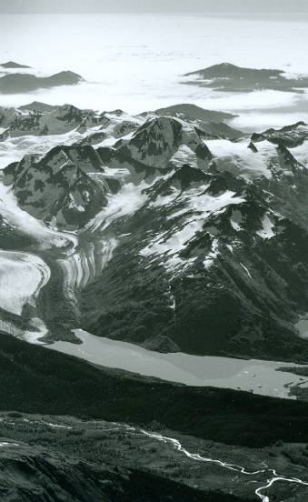
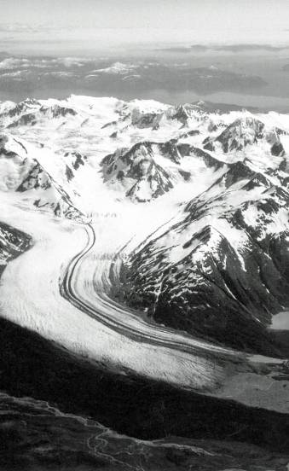
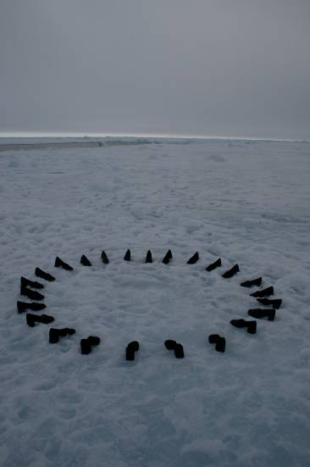
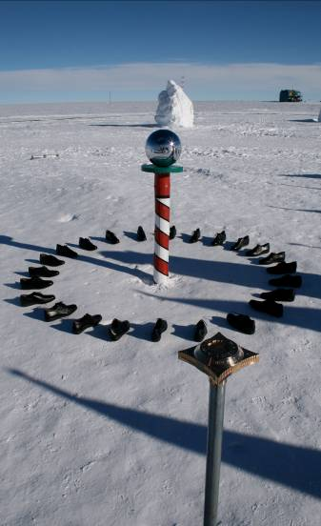

Xavier Cortada, Longitudinal Installation at the South Pole (2006) and North Pole (2007) Photo: Xavier Cortada. 1938 20-Mile Glacier No. 1612. Photo: U. of Alaska Archives. 2007 20-Mile Glacier. Photo: David Arnold

Understanding & Communicating
the Science of Climate Change
Providing grass roots information for teachers, students
and community members across America

WHEN: Sunday, April 5th - Tuesday, April 7th, 2009 (agenda attached)
WHERE: San Francisco's Exploratorium or on the web: www.exploratorium.edu/webcasts www.explo.tv www.exploratorium.edu/echo
WHO: People studying the effects of climate change, including educators, scientists, artists and policy makers

FOR: The general public, especially students in grades 6 - 12

The Iñupiat of the Arctic Slope are on the front lines of the battle against global
climate change, but they are not the only people affected by the warming of the planet. The ECHO (Education through Cultural and Historic Organizations) Partners symposium will discuss without jargon or overly technical language the effects of climate change on our environment. Join scientists, artists, educators and ECHO partners from Alaska, Hawaii, Mississippi and Massachusetts as we develop an effective strategy for clearly communicating and educating our global community on the science of climate change.


The ECHO Climate Change Symposium will be permanently available and archived by the
Exploratorium at www.exploratorium.edu/echo . Barrow Arctic Science Consortium (BASC)
www.arcticscience.org is symposium facilitator; the Exploratorium is our national host.

