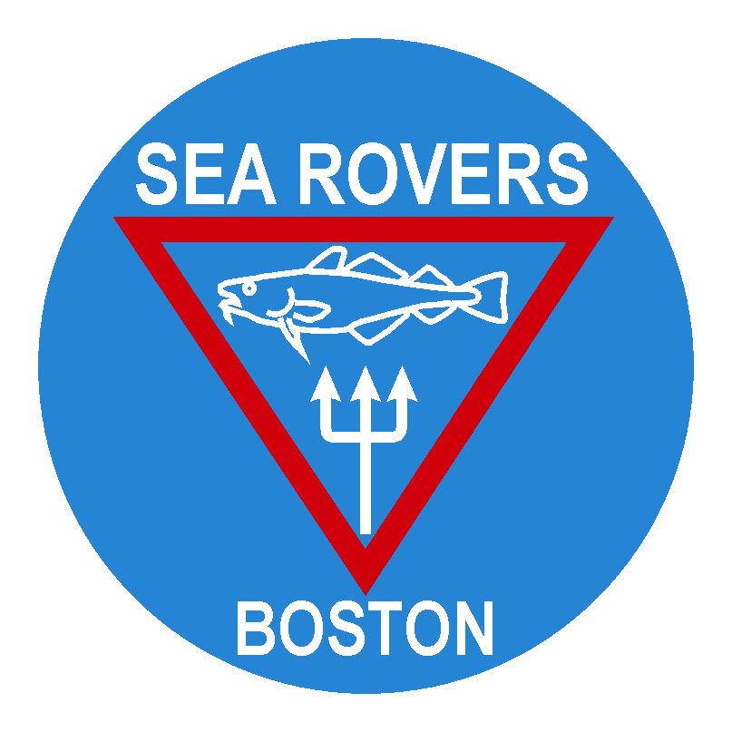

Frank Scalli Annual Summer Internship
The Boston Sea Rovers are currently accepting applications for the 2009 Frank Scalli Annual Summer Internship. Qualified graduating high school seniors and college freshman interested in pursuing underwater careers are encouraged to apply to the Sea Rovers by October 31, 2008.
Immediately following graduation or the spring semester, the 2009 recipient will intern with members of the Boston Sea Rovers and associates located throughout the United States to experience a wide variety of jobs and career choices. Based in part on the personal interests of the scholar, the Internship will provide advanced dive training courses and ample opportunities to dive and train with a variety of dive professionals in a broad cross section of diving environments. Opportunities will include hands-on work with professional underwater photographers and filmmakers, educational specialists, marine engineers and scientists, equipment manufacturer’s representatives, and dive shop owners.
In addition to the unique time spent with some of our most distinguished members, the Scalli Intern will be outfitted with dive equipment (provided by Sea Rover Clinic corporate sponsors) for their use throughout the summer and will receive the necessary financial support to ensure travel and living expenses.
A six-member Board comprised of Sea Rovers and the Scalli family selects each year’s intern. To be considered for the Scalli Internship, candidates must:
- be a certified diver from New England;
- have earned a minimum GPA of 3.4 out of 4.0 (or equivalent) and be on track to graduate from high school by June of the Internship year or attending college at the time of application;
- be 18 years old by the beginning of their Internship;
- and submit a complete scholarship application package that includes an essay on why the candidate wants to pursue a career in the underwater world and how this scholarship can help them achieve that goal.
Interested candidates should visit our website, www.bostonsearovers.com to see what previous interns experienced.
Contact Vin Malkoski (vmalkoski@verizon.net or 508-748-3107) for an application package. The Sea Rovers must receive all packages by October 31, 2008.
Good luck and we look forward to receiving your application.

