Planners, Conservationists, Developers, & citizens are invited to a presentation about:
Open Space Residential Design  Thursday, October 9th, 2003  South Shore Science Center in Norwell  9:00 to 11:00 am | 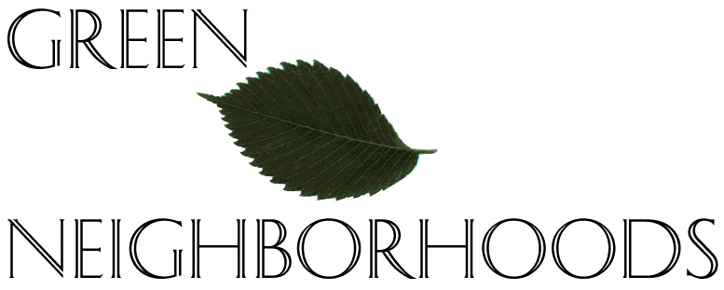  Presented by:

The Green Neighborhoods Alliance is a group of planners, realtors, developers and conservationists on the North Shore of Massachusetts who support community preservation and smart growth initiatives. With the help of the Metropolitan Area Planning Council, the Alliance has written a model bylaw/ordinance known as “Open Space Residential Design”, an alternative to the large-lot subdivisions that are consuming open space at an alarming rate. The OSRD is a four-step planning process based on the work of Randall Arendt, that offers to replace what is an often cumbersome, lengthy, costly and sometimes antagonistic subdivision permitting process with one that invites innovation and results in a higher quality subdivision design.

OSRD is not like older cluster bylaws and ordinances, because it sets aside open space based on resource values, not by formula. Also, there are two OSRD bylaw options – by right and special permit. Unlike some cluster bylaws, OSRD is written to ease the approval process, making the approval process for OSRD less cumbersome and on par with the approval process for conventional subdivisions.

Representatives from the Green Neighborhoods Alliance will share their experiences, materials, and case studies to help South Coastal communities understand and implement OSRD. For more information about OSRD and Green Neighborhoods, please visit http://www.greenneighborhoods.org.
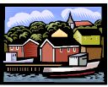
This presentation is part of the Fall 2003 Green Communities Lecture Series, brought to you by the South Coastal Watershed Network. We are an informal group of citizens, local officials, nonprofit organizations, and government agencies that work together to protect our region’s water resources. The SCWNetwork is coordinated by the Massachusetts Bays National Estuary Program, the North and South Rivers Watershed Association, and the Massachusetts Office of Coastal Zone Management.

Please register. There is no charge to attend the lecture series, but space is limited.
To register for part or all of the lecture series, please visit http://www.nsrwa.org/greencommunities.html. Or contact Wendy Garpow, South Shore Regional Coordinator of the Mass Bays Program, at #781-659-8168 or wendy@nsrwa.org. If you register by email, please provide name, title/organization, address, email, and phone.

Directions to the South Shore Natural Science Center: From Route 3 -- Take exit 13 (Hanover Mall/Norwell). At end of exit ramp, turn NORTH onto Route 53. At first traffic light, turn right on Route 123 (Main Street). Take first left onto Jacobs Lane (just past the pond). The Science Center is 1/4 mile on your right.

The Green Communities Lecture Series (Autumn 2003) is sponsored by:
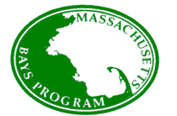
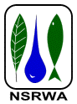

Massachusetts Office of
Coastal Zone Management
Massachusetts
Bays National Estuary Program (Mass Bays Program)
North and
South Rivers Watershed Association

