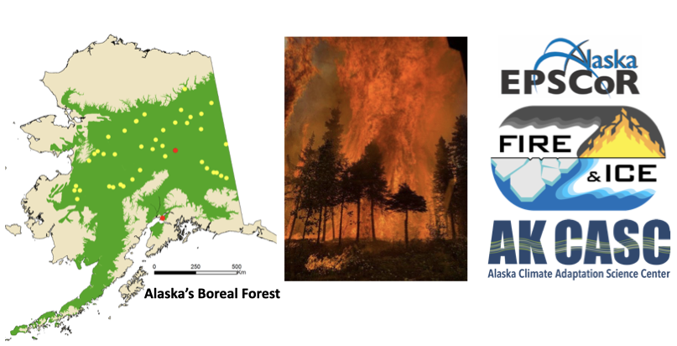

Post-Doc Position in Climate Variability

The Geophysical Institute (GI) and the International Arctic Research Center at the University of Alaska Fairbanks are seeking applications for a two-year Post-Doctoral Fellow in climate variability/dynamics. The successful candidate will be part of an exciting collaboration between Alaska EPSCoR (Established Program to Stimulate Competitive Research; www.alaska.edu/epscor/) and the Alaska Climate Adaptation Science Center (AK CASC; casc.alaska.edu). This position is affiliated with the GI's Atmospheric Science Group (www.gi.alaska.edu/research/atmospheric-sciences) and with the International Arctic Research Center (IARC), where AK CASC is located.

EPSCoR (www.alaska.edu/epscor/) is a $20 million, 5-year National Science Foundation cooperative agreement that supports interdisciplinary research to build capacity in the State of Alaska. The project is titled “Fire and Ice: Navigating Variability in Boreal Wildfire Regimes and Subarctic Coastal Ecosystems” and includes a significant research effort to develop seasonal outlooks based on weather/climate and wildland fuel conditions.

The Alaska Climate Adaptation Science Center (AK CASC; casc.alaska.edu) is one of 8 regional Climate Adaptation Science Centers (https://www.usgs.gov/land-resources/climate-adaptation-science-centers) that provide managers of fish, wildlife, and ecosystems with the tools and information they need to develop and execute management strategies that address the impacts of climate change on natural and cultural resources. Hosted by UAF with a USGS hosted office in Anchorage, AK CASC provides scientific information, tools, and techniques that managers in Alaska and others interested in land, water, wildlife and cultural resources can use to anticipate, monitor and adapt to climate change.

This postdoctoral fellowship provides an opportunity to co-produce actionable science that addresses the growing needs of the Alaska wildland fire management community. The successful candidate will conduct cutting-edge climate variability research relevant to understanding the predictability of summer fire weather in Alaska. We seek candidates with a strong research publication record, excellent communication skills, ability to work on team-science, and data analysis skills (e.g., ability to write codes for analyzing climate data), and the ability to work in an interdisciplinary team setting.

DUTIES
A candidate with expertise in climate diagnostics and variability research is sought to work on investigating the predictability of summer fire weather conditions using observational data as part of the of the Alaska EPSCoR project. Duties include working with the project team on climate dynamics research, co-production of knowledge, and publishing.

QUALIFICATIONS
Applicants should have a PhD degree in atmospheric or oceanic sciences, climate dynamics, or a related discipline at the time of hiring. A strong background in Arctic climate is desirable. Experience in working with large data sets is required. Strong interpersonal and communication (oral and written) skills are necessary. Climate modeling experience is a plus.

CONDITIONS
The position is temporary for 2-years with a potential for a third year. The salary will be determined according to qualifications and work experience. To ensure consideration please apply by 09/30/2020 through the Careers at UA site. Formal evaluation of candidates will begin on 10/1/2020. For further questions about this position please contact Drs. Peter Bieniek (pbieniek@alaska.edu), Todd Brinkman (tjbrinkman@alaska.edu), or Uma Bhatt (usbhatt@alaska.edu).

Direct link of the job announcement and online application site is https://careers.alaska.edu/en-us/job/515424/geophysical-institute-climate-variability-post-doc.

