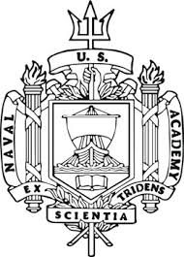

United States Naval Academy

To:

From:

As chair of the Physics Department at the US Naval Academy, I would like to make you aware of our desire to hire an acoustician this year. This would likely be a tenure track position at the Assistant Professor level.

The Naval Academy has a long record of research in physical acoustics, and we are seeking a new member to continue this vision. I want to highlight what we can offer to a prospective candidate, and I would appreciate it if you could forward this to any post docs or graduate students who may be interested in this position. Enclosed is a 30 cm wide by 45 cm tall poster (in pdf form) that highlights the announcement of the position.

Graduate students finishing up their thesis defense by August 2020 would fit the starting time of mid-August 2020. The official job advertisement can be found at the following web address

<https://www.usna.edu/HRO/jobinfo/PHYS-TenureTrack-AY2020.php>

About the Naval Academy

* The U. S. Naval Academy (USNA) is located on the Severn River in Annapolis, Maryland. The city of Annapolis, is quite picturesque and has a historic small town feel to it.
* USNA is a fully accredited undergraduate school with majors and honors programs in many disciplines, including the humanities, languages, engineering, as well as chemistry, computer science, cyber security, math, oceanography, and physics. These latter six make up the Division of Mathematics and Science.
* The brigade of Midshipmen is typically 4400
* All students take a core curriculum (math, science, engineering and humanities, leadership) throughout their academic journey along with their major, which they select just prior to their sophomore year.

Attributes of a good search candidate include

* enjoy teaching,
* enjoy doing research with motivated and talented students,
* would like to teach small class sizes (24 maximum),
* being creative in their very own acoustics laboratory space,
* would enjoy being a mentor to undergraduate physics majors,
* would enjoy the challenge of advising these future leaders,
* would enjoy giving demos in class,
* would enjoy sharing their teaching philosophies with other physic faculty members or just collaborating if possible.

Research Facilities

* Acoustics has a large foot print in our laboratory spaces
* We have **two anechoic chambers**, which are shown below:

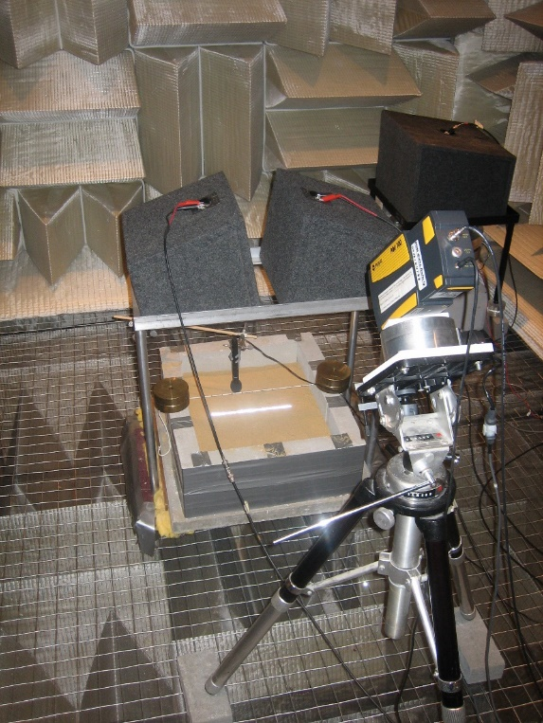 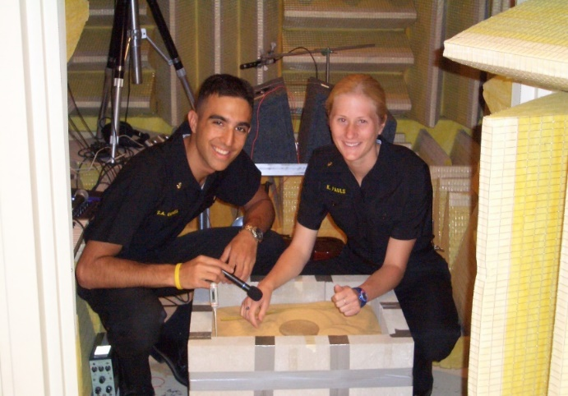

Anechoic Chamber #1 Anechoic Chamber #2

* There is lab space that is used for both the acoustics course and research projects
* The Naval Academy is committed to providing professors time to perform research (some of which should include undergraduates) – professors teach two courses each semester where the class size is capped at 24 students
* Summer salary is guaranteed for the first two summers to help young professor develop a plan that may lead to an external grant, which may come from the Office of Naval Research, the National Science Foundation, etc.

Teaching Opportunities

* A Physical Acoustics course is offered every year and typically attracts ~10 physics majors
  + The professor has full control of this course and may choose the topics that she/he feels best represent the field
  + This is a lab-based course, and facilities are available to provide students quality lab experiences in acoustics
* In addition, an Underwater Sonar course is offered during both semesters that is taken by Oceanography and General Science majors
  + The professor will coordinate with the Oceanography department to be sure the topics covered satisfy their requirements
* A new Acoustics faculty member will likely be asked to teach the introductory physics courses for a year or two before they begin in the Acoustics and Sonar courses
* Physics majors are strongly encouraged to perform research during the year, and faculty members are expected to provide such opportunities

Department/Academy

* The Physics Department has ~25 civilian and ~10 military members
* The faculty are active in many research fields including Acoustics, Astrophysics, Atomic/Molecular, Condensed Matter, Nuclear, and Optics
* Several members have been successful in obtaining grants from the Office of Naval Research, the National Science Foundation, the Department of Energy, and NASA
* The laboratories in the Baltimore/Washington area, including the Army Night Vision Lab (Fort Belvoir, VA), the Army Research Lab (Adelphi, MD) and the Naval Research Lab (Washington, DC) have funded acoustic programs in both the past and present.
* We offer a very supportive environment for our young professors, we are committed to providing them the best chance for a successful career at the US Naval Academy.

Physics at USNA

* The Department typically graduates 25-30 majors each year.
* The Physics Majors enjoy spending part of their summer doing internships across the country at major lab facilities.
* The Physics Dept. is highly ranked when compared to undergraduate schools and has been considered to be one the largest physics departments in the country.
* While Physics has a majors program including an honors program at USNA, faculty members in physics in all research fields (see the list above) get to teach the core physics curriculum (SP211, SP212) to all 1000 or so sophomores (non-physics majors) in the entire brigade of Midshipmen.
* These course are called General Physics I (typically Halliday & Resnick mechanics) and General Physics II (typically Halliday & Resnick electricity, magnetism and optics). They are both fun and challenging to teach – as we expect the students to learn the material and be able to spring board to other technical courses in the core curriculum.
* The Physics Department faculty members are very collegial and offer a supportive environment to both young and seasoned faculty.
* Whether the candidates field involves physical acoustics, medical ultrasound, underwater sound, applied physics aspects of sound, acoustical oceanography, animal bioacoustics, or engineering fields of acoustics that involves physical acoustics, (just to mention a few areas) the candidate with an acoustics background should feel welcome to apply for the position.

For more Information Contact:

Physics Dept Chair: Professor DaryL Hartley

Tel: 410-293-6651

E-mail: hartley@usna.edu