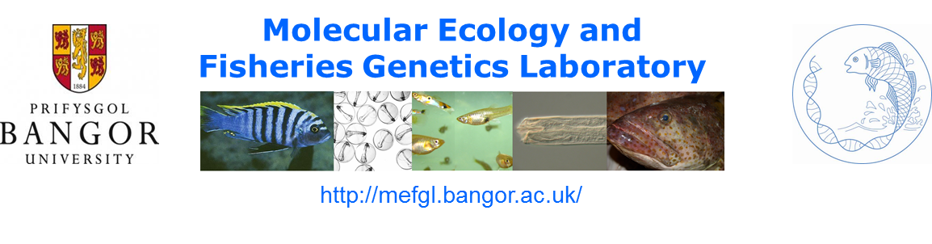
Lectureships in Zoology, School of Biological Sciences, Bangor, UK

The School of Biological Sciences is currently hiring for 3 permanent faculty positions at the Lecturer level. In particular, the Molecular Ecology and Fisheries Genetics Laboratory (http://mefgl.bangor.ac.uk/) will be seeking new team members and collaborators to join existing faculty and strengthen research capability. Current Principal Investigators comprise Gary Carvalho, George Turner, Si Creer, Wolfgang Wüster and Anita Malhotra with interests spanning fisheries genetics, speciation, venom/genome evolution, pollinators, phylogeny, systematics and a diverse array of environmental genomics applications. The MEFGL is housed in the bespoke, recently constructed Environment Centre Wales Building (ECW), linking the MEFGL to the Schools of Ocean Sciences, Environment, Natural Resources and Geography and the NERC Centre for Ecology and Hydrology (CEH), facilitating a host of collaborative opportunities. The MEFGL benefits from fully equipped molecular labs, second and third generation sequencing capability at the Liverpool Centre for Genome Resarch (http://www.liv.ac.uk/genomic-research/) and access/bioinformatic development capability on the HPC Wales supercomputing genomics gateway.

In addition to exploring fundamental issues in molecular ecology and evolution, the MEFGL contributed significantly to the 2014 UK Research Excellence Framework (REF) exercise, through both the inclusion of high impact outputs, and in the provision of an Impact Case Study focusing on wildlife forensics and traceability in marine fisheries. The MEFGL also contributes significantly at an international level, with members on the editorial teams of leading journals in the field, such as Proceedings of the Royal Society Lond. B, Molecular Ecology, Molecular Ecology Resources, Fish and Fisheries, and Conservation Genetics. It is hosting in September the annual meeting of the UK Environmental DNA (eDNA) working group, preceded by a training workshop in eDNA for Indonesian colleagues. The MEFGL is also coordinating a major international symposium on Fish, Genes and Genomes in July 2016 with leading key-note speakers such as Axel Meyer, Robin Waples, Craig Primmer, Louis Bernatchez, Jenny Ovenden and John Casey. More broadly, research in the School of Biological Sciences is ranked in the top 20 Universities in the UK (2014 REF). Across the University, three-quarters of Bangor’s research is either world-leading or internationally excellent.

The University hiring remit is very broad to enable the selection of the strongest candidates. Applications from candidates in the fields of molecular ecology, evolutionary biology and genomics in its broadest sense are welcomed and most likely competitive, in light of the Research Excellence Framework (REF) process. The lectureships are branded as “Zoology” reflecting the composition of our degree portfolios, but we would encourage you to think and apply strategically with the research focused hires.

Where is Bangor?
Bangor is located in North West Wales, UK, situated in an area of outstanding natural beauty between Snowdonia National Park and the sea (http://www.bangor.ac.uk/bangortv/bangorandthearea.php), providing an opportunity for a very high standard of living amongst a spectacular natural environment. International links are facilitated easily via both Liverpool and Manchester airports and London is just over 3 hours away via high speed trains.

The closing date for applications is 10th August 2015 and the application process can be found at https://jobs.bangor.ac.uk/, job reference: BU00844.

Any questions, please pay a visit to the MEFGL website http://mefgl.bangor.ac.uk/ and liaise with your chosen investigator.

