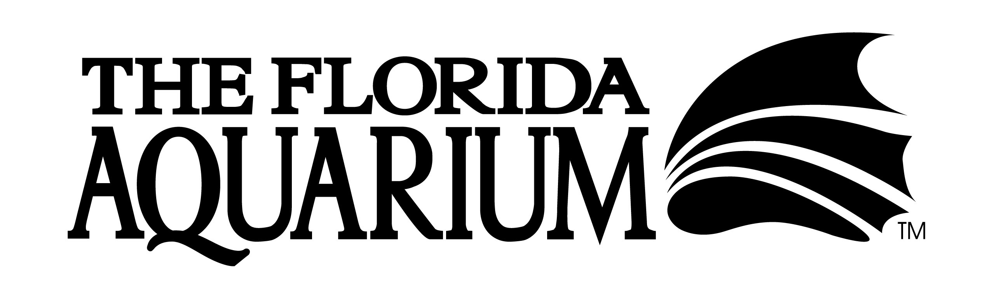
POSITION DESCRIPTION

Position Title: Community Programs Coordinator
Service Group: Education
Reports To: Youth Education Manager
Exemption Status: Exempt
Grade: 8

Position Summary
Responsible for development and daily management of community programs, which include camps, birthdays, tots and scout programs. Plans and implements community programs. Ensures that all community programs are innovative and effective and in direct support of the purpose/vision/ mission/values of The Florida Aquarium. Maintains relationships with outside partners for programming and maintains accurate expense records for reporting purposes. Enhances community awareness of programming through marketing efforts. Oversees budgets and materials. Trains and oversees salaried instructors, lead party host, summer camp staff, volunteers, and interns. Designs and implements training for staff. Teaches school and community programs.
Essential Position Functions
- Monitors marketing and evaluation of community programs through development and distribution of materials (brochures, flyers, catalogs, questionnaires) and promotion of programs through calls, events, and other awareness outlets.
- Develops/implements strategies to exceed all community programs goals.
- Develops and conducts high quality community programs.
- Works with Reservations to ensure that program records and revenues are accurately recorded.
- Interviews, hires, coaches and disciplines direct reports.
- Trains, oversees, and evaluates community program staff, interns and volunteers.
- Identifies education staff and intern projects to improve community programs.
- Provides training and support to camp staff prior to camp and during camp.
- Teaches school, outreach and community programs as needed.
- Maintains the highest level of quality for the Aquarium's camp/tot programs and image.
- Develops and maintains local and regional professional contacts at partner organizations.
- Acts as liaison to other Aquarium departments to insure that all program needs are met. (i.e. food service, animal encounters, Explore A Shore)
- Provides front-end, formative, and summative evaluations of camp/tot programs.
- Acquires and maintains supplies, books, props, and activities for camp/tots programs.
- Represents the Aquarium at conferences, speaking engagements, and community events.
- Presents formal papers at conferences and articles for publication when possible.
- Serves on committees relating to camp programs as needed.
- Prepares and submits written reports, proposals, and recommendations as required.
- Delivers extraordinary customer service to all Aquarium guests and staff.
- Other duties as assigned by manager.

Education Requirements and Technical Skills
- Minimum of two years management experience preferred.
- Minimum of two years of progressively responsible professional experience working with camp staff and conducting community programs.
- Four-year degree in life sciences, education, or related field.
- Teaching and curriculum development experience in an informal setting.
- Ability to work with mammals, birds, reptiles, amphibians, fish, and invertebrates for use in camp programs.
- Ability to manager, organize, and plan a large program.
- Possession of valid Florida driver's license.
- Knowledge of Microsoft Office software.
Competencies
- Customer Service Orientation: Listening and understanding the customer (both internal and external) and anticipating and evaluating the customer's needs.
- Teamwork: Supporting, facilitating, and participating in activities that promote team success.
- Concern for Detail: Paying attention to every portion of any task, down to the smallest item.
- Work Standards: Applying high performance standards to all work-related activities.
- Communication (oral and written): Effectively expressing ideas and actively listening to others; focusing presentations to needs of audience; expressing ideas clearly and concisely in written form, through memoranda, letters, reports, and other documents.
- Creativity: Proactively combining ideas, resources, and skills in new ways to better meet outcomes and objectives; finding ways to position the Aquarium as a model of excellence.
- Information Gathering and Monitoring: Effectively collects relevant data using questioning or research techniques to monitor and manage projects and people.
- Planning and Organizing: Establishing a course of action with specific long-range goals for the Aquarium; setting priorities among competing requirements and allocating resources in efficient and effective ways; developing plans that anticipate changes in work environment.
- Follow-up: Institutes methods for monitoring people and projects.
Typical Physical Requirements
- Sitting (2 hours per day)
- Standing (3 hours per day)
- Walking (3 hours per day)
- Viewing a computer screen for extended periods
- Typing on a computer keyboard
- Bending/Stooping/ Squatting/ Crouching — Frequently
- Crawling — Occasionally
- Reaching above shoulders — Frequently
- Pushing/Pulling — Frequently
- Carrying and/or lifting up to 50 lbs — Occasionally
- More than normal talking
- Ability to maintain daily contact with living collection of plants and animals
- Exposure to marked changes in temperature and humidity
- Daily contact with living collection of plants and animals in a central Florida climate
- Ability to interact with and be around wild animals
- Subject to bites, stings, and scrapes
- Ability to travel (van) as needed
- Flexibility in working weekends, evenings, and holidays
- Available for on-call emergencies

