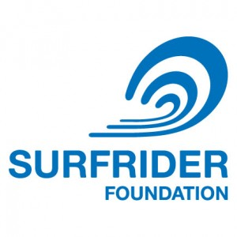
Unpaid Internship: Mid-Atlantic Ocean Recreation Outreach Coordinator

The Surfrider Foundation seeks a Mid-Atlantic Ocean Recreation Outreach Coordinator to support stakeholder engagement in regional ocean planning in the Mid-Atlantic (NY to VA). The position’s main responsibility is to identify, communicate with, and engage recreational interests throughout the Mid-Atlantic in the ocean planning process of the Mid-Atlantic Regional Planning Body (RPB). The intern will work under the direction of Matt Gove (Mid-Atlantic Policy Coordinator) and Pete Stauffer (Ocean Program Manager) and require 5-10 hours per week for 6-12 months.

Position Responsibilities:
- Identify groups, associations, and businesses that broadly represent ocean and coastal recreation in the Mid-Atlantic
- Conduct outreach to recreation interests by email and other media, phone, and in-person meetings on ocean planning and Surfrider’s engagement in the process
- Organize workshops and public forums to present data from Surfrider’s recreational use study and solicit feedback on draft maps and other study products
- Promote opportunities for the recreation sector to participate in ocean planning through public meetings, comment periods, and workshops.
- Manage and update the Mid-Atlantic Recreational Gatekeeper Database
- Implement a social media campaign to promote engagement of recreational users in the ocean planning process
- Develop outreach materials for recreational users on regional ocean planning
- Meet and collaborate with project partners including Monmouth University, The Nature Conservancy, and Point 97/Ecotrust

Desired Qualifications:
- Working towards or have completed an advanced degree in ocean/coastal policy or communications
- Ability to communicate effectively with ocean stakeholders, using both in-person and written strategies
- Proficient with Facebook, Twitter, MailChimp, and other digital communications
- Knowledge of ocean and coastal recreation in the Mid-Atlantic
- Ability to work flexible hours from a home office or on the road
- Proficient in Microsoft Word, Power Point, and Excel
- Access to a vehicle

To Apply:
Interested candidates should email a cover letter and resume by January 22nd 2014 to: Matt Gove at mgove@surfrider.org

