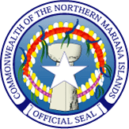
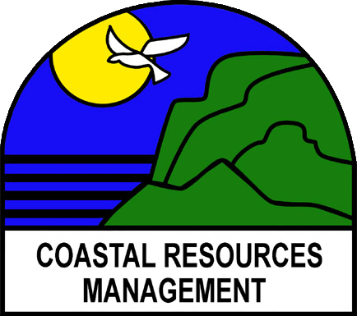

Commonwealth of the Northern Mariana Islands

Coastal Resources Management

Caller Box 10007CHRB, Coastal Resources Facility

Susupe, Saipan, MP 96950

Website: www.crm.gov.mp Tel (670)664-8300

Fax (670)664-8315

JOB VACANCY ANNOUNCEMENT

Coastal Resources Management Office currently has a vacancy for Coastal Resources Planner. Interested applicants should e-mail their resumes to rita.chong@crm.govmp on or before June 3, 2013.

NATURE OF WORK: The duty station for this position will be located at the Coastal Resources Management Office on Saipan and is under the direct supervision of the Lead Coastal Planner. The Coastal Planner collaborates with Planners from other Environmental agencies.

DUTIES AND RESPONSIBILITIES

- Responsible for the implementation of any assigned projects that fall under NOAA’S Program Changes Grants Program (CZMZ Section 309) in any of the following categories: wetlands, coastal hazards, public access, marine debris, special area management planning, ocean resources, cumulative and secondary impacts, energy and government facility siting and aquaculture.
- Participate in grant writing efforts within the Planning section.
- Lead the development of plans and projects that meet both local and federal wetlands standards for wetland protection.
- Perform education and outreach as outlined in federal funding objectives that relate to watershed planning, NPS, wetland protection, habitat restoration, and other coastal management issues.
- Coordinate development of plans and strategies to implement the CZMA program in the CNMI.
- Prepare monthly and quarterly activity reports.
- Monitor, track and evaluate implementation of assigned projects within the planning section.
- Coordinate CRM Planning activities with relevant CNMI, regional and federal partners.
- Assist with review and comment of permit applications with regard to impacts on wetlands, coastal hazards, public access, marine debris, special management planning, ocean resources, cumulative and secondary impacts, climate change, energy and government facility siting, and aquaculture.
- Assist with the coordination of the annual CNMI International Coastal Cleanup activities in the CNMI.
- Coordinate project activities with CRM Grants Program Manager to ensure proper Procurement procedures are followed and to ensure fiscal accountability of projects funds.
- Assist with the coordination of the CRM Clean Beaches campaign activities.
- Participate in the coordination of Climate Change adaptation planning and strategy development within CRM, in coordination with relevant stakeholders.
- Participate in CRM education and outreach activities.
- Performs other duties as assigned.

QUALIFICATIONS

Education:

A Bachelor’s degree in Science in Engineering, Architecture, Geology or Geotechnical Science, Natural Resources Management, Land use Planning or similar.

Experience:

At least two years of professional experience in work relevant to this position such as: natural resources or environmental planning or coordination; community watershed planning, watershed assessment; or implementing nonpoint pollution program.
A Master’s degree in one of the above fields may substitute for the bachelor’s degree and required professional experience.

Must possess following skills:

- Operate computer, telephone, network copy machine and printer, calculator, facsimile machine, projector and digital cameras.
- Use standard agency computer applications as needed including digital permits and GIS maps and information, e-mail, Office word processing, spreadsheet and databases.
- Good oral and written communications.
- Must have public speaking and or group facilitation skills.
- Must be able to communicate effectively in writing.

Salary:

$30,000 to $34,000 per annum plus fringe benefits.

