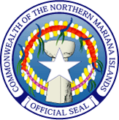
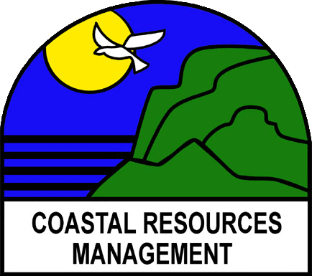

Commonwealth of the Northern Mariana Islands

Coastal Resources Management

Caller Box 10007CHRB, Coastal Resources Facility

Susupe, Saipan, MP 96950

Website: www.crm.gov.mp Tel (670)664-8300

Fax (670)664-8315

JOB VACANCY ANNOUNCEMENT

Coastal Resources Management Office currently has a vacancy for a Lead Coastal Resources Planner. Interested applicants should e-mail their resumes or inquiries to rita.chong@crm.gov.mp on or before June 3, 2013, 2013.

NATURE OF WORK: The duty station for this position will be located at the Coastal Resources Management Office on Saipan and is under the direct supervision of the Administrator. The Lead Coastal Planner leads and provides coordination for the Planning section at CRM and works most closely with the GIS Specialist, Coastal Resource Planner, Coastal Coordinators and the Grants Program Manager.

DUTIES AND RESPONSIBILITIES

- Lead implementation of all projects that fall under NOAA’S Program Changes Grants Program (CZMA Section 309) in any of the following categories: wetlands, coastal hazards, public access, marine debris, special area management planning, ocean resources, cumulative and secondary impacts, energy and government facility siting and aquaculture.
- Provide coordination for planning projects including: coordinating with partner agencies; integrating work plans and budgets; facilitating stakeholder committee meetings; assisting with contracting for special studies; supporting outreach to the general public.
- Coordinate grant writing efforts with Grants Program manager to obtain additional funding for any aspect of CRM work.
- Lead the development of plans and projects that meet both local and federal wetlands standards for wetland protection.
- Perform education and outreach as outlined in federal funding objectives that relate to watershed planning, NPS, wetland protection, habitat restoration, and other coastal management issues.
- Coordinate development of plans and strategies to implement the CZMA program in the CNMI.
- Coordinate with CRM permitting section to review permit applications for compliance with CRM Wetland and NPS regulations.
- Prepare monthly and quarterly activity reports.
- Monitor, track and evaluate implementation of projects within the Planning section.
- Coordinate CRM Planning activities with relevant CNMI, regional and federal partners.
- Coordinate outreach and education regarding regulation changes.
- Coordinate the annual CNMI International Coastal Cleanup activities in the CNMI, with Coastal Coordinators on Tinian and Rota.
- Coordinate project activities with CRM Grants Program Manager to ensure proper Procurement procedures are followed and to ensure fiscal accountability of projects funds.
- Lead the coordination of the CRM Clean Beaches campaign activities.
- Lead the coordination of Climate Change adaptation planning and strategy development within CRM, in coordination with relevant stakeholders.
- All other duties as assigned by the Director.

QUALIFICATIONS

Education:

Graduation from an accredited college or university with a bachelor’s degree in Natural Resources Management, Land Use planning, Biology, Geography, Engineering ( Civil/Environmental) or related environmental field.

Experience:

Three years of professional experience in work relevant to this position such as: natural resources or environmental planning or coordination; community watershed planning; watershed assessment; or implementing nonpoint pollution program. Also relevant project management experience required.
A Masters degree in one of the above fields may substitute for the bachelor’s degree and required professional experience.

Must possess following skills:

Operate computer, telephone, network copy machine and printer, calculator, facsimile machine, projector and digital cameras.
Use standard agency computer applications as needed including digital permits and GIS maps and information, e-mail, Office word processing, spreadsheet and databases.
Good oral and written communications.
Must have public speaking and or group facilitation skills.
Must be able to communicate effectively.

Salary:

$35,000 to $40,000 per annum plus fringe benefits.

