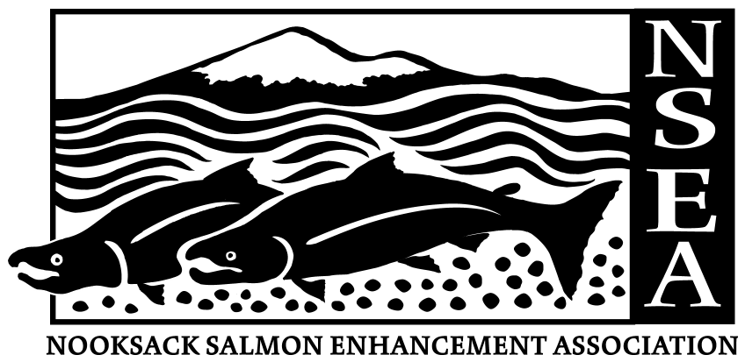

Nooksack Salmon Enhancement Association (NSEA)
2445 E. Bakerview Rd.
Bellingham, WA 98226

JOB ANNOUNCEMENT: Program Coordinator, Citizen Action Training School

In 1990, the Washington State Legislature created the Regional Fisheries Enhancement Group (RFEG) Program to involve local communities, citizen volunteers, and landowners in the state's salmon recovery efforts.
As one of the 14 RFEGs, NSEA is a community-based 501(c)3 nonprofit organization with a mission to restore sustainable wild salmon runs in Whatcom County. As one of the 14 RFEGs in Washington State, NSEA participates in on-the-ground stream restoration efforts as well as educating and involving the public in community-based salmon recovery activities.

Position Description
This position will coordinate a two-year program developed by the seven RFEGs that surround Puget Sound. This program, known as the Citizen Action Training School (CATS), will protect and improve the Sound’s water quality and marine resources through two phases: 1) teaching residents of the twelve counties bordering the Sound about their local watersheds and how to better engage in the civic process, and 2) providing them with the opportunity to act with that knowledge. The CATS program is funded by a grant from the Puget Sound Partnership program with monies from the U.S. Environmental Protection Agency.

The program will consist of a series of 12-week workshops in each RFEG area, providing up to 30 volunteers in each area with quality training in natural ecology, jurisdictional issues and public process of both the Sound and the greater Salish Sea. After completion of this fifty hours of training, each volunteer will donate fifty hours back to their community in a mutually-agreed upon project which will address one or more important issues facing their watershed.

To implement this project, the Program Coordinator will be expected to arrange the workshops in each county with the individual RFEGs and ensure that local concerns and solutions are being appropriately addressed, create a syllabus for each county’s individual program, obtain commitments from expert presenters after vetting them and confirming that they understand their role and anticipated contribution, market the program and enroll participants in each county, ensure smooth delivery of the workshops, assist the volunteers in selecting projects, ensure completion of the individual projects and provide a final evaluation and report of the program. The incumbent will report to the Executive Director of NSEA and an advisory group of RFEG staff.

The Program Coordinator will be a ¾ time employee of the Nooksack Salmon Enhancement Association (NSEA), which is one of the seven Puget Sound RFEGs, and will be based in Bellingham, WA. This position will begin March 1st, 2013 and will expire on June 15th, 2015with the potential to continue this program based on available funding.

NSEA is an equal opportunity employer committed to workplace diversity, and offers an excellent benefits package. For more information about NSEA, please visit our website at www.n-sea.org.

SALARY RANGE: Salary & Benefits DOQ

WHERE TO APPLY: Applications may be emailed to rvasak@n-sea.org or hand-delivered or mailed to: Rachel Vasak, Executive Director, Nooksack Salmon Enhancement Association, 2445 E. Bakerview Road, Bellingham, WA 98226, and must be received no later than 4:30 PM on 2/13/13.

CONTACT: Rachel Vasak - rvasak@n-sea.org for questions regarding this position.

MATERIALS REQUIRED: Submit resume, three references, and a cover letter that includes specific examples of past work experience that demonstrate your ability to meet or exceed the position requirements.

OFFICE LOCATION: 2445 E. Bakerview Road, Bellingham, WA 98226

RESPONSIBILITIES:
- Establish a working relationship with the Puget Sound Caucus of the RFEGs; become acquainted with significant issues affecting the watersheds in each of the twelve counties associated with these RFEGs. These issues include, but not exclusively, land development, habitat preservation, ecological conservation, local economic drivers, sustainable agriculture, watershed planning, tribal resources, key laws and regulations, and related scientific information. The Puget Sound Partnership Action Agenda should be a guiding document in the development of an overall curriculum.

- Develop seven 12-week workshops for up to 30 participants each, including arrangements for venues and other logistics, and write syllabus for each.
- Arrange for professionals to present at each of these workshops; vet, and provide clarity to each presenter for their expected contribution; subsequently acknowledge each for their contribution.
- Arrange for appropriate field trips including transportation, ensuring participant safety.
- Develop an applicant selection process.
- Market program in each RFEG area, select applicants and acquire commitment to complete program.
- Travel to other RFEG groups to assist with workshops (travel costs & per diem will be provided)
- Ensure smooth delivery of each workshop.
- Maintain working relationships with local media for publicity purposes.
- Maintain records of each workshop and applicant project.
- Develop parameters around project selection by participants for their 50-hour contribution phase; create list of potential projects suggested by RFEGs and by resource professionals or others.
- Consult with workshop participants for their project selection (effective and reasonable in scope to ensure completion) and determine a targeted outcome or establish performance measures to enable identification of project completion; acquire commitment and ensure participant has resources to attain completion.
- Monitor participant’s project success; serve as a resource in the case of questions, problems, or need to modify project.
- Develop effectiveness and implementation monitoring systems.
- Periodically report progress to the NSEA Executive Director or as directed, and complete final reporting requirements. Provide updates to individual RFEGs concerning workshop progress in their area.

QUALIFICATIONS:
- Bachelor’s degree or equivalent.
- Experience with governmental or nonprofit organizations, especially those in the environmental conservation arena, including a successful history of working with environmental programs and projects.
- Demonstrated track record of project development and completion within a budget; ability to conduct complex projects.
- Familiarity with Puget Sound environmental issues, including governmental and other organizations, including the Puget Sound Partnership Action Agenda.
- Ability to establish working relationships with people from many walks of life, and an ability to encourage others to complete their own projects.
- Excellent verbal and written communication skills, including presentations.
- Familiarity with online media and computer skills.
- Familiarity with the print and electronic media.
- Strategic thinker, experienced in developing goals and schedules and in meeting deadlines.
- Self-starter, self-directed and self-motivated.

