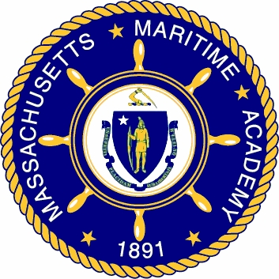
One of nine state colleges of the Commonwealth

Position: Full-time, tenure-track
Chemistry faculty

Posting: April 2011 Start date: 01 September 2011
Position Number: FY10-15
Division: Academic; Science and Mathematics Department
Union Affiliation: Massachusetts State College Association (MSCA)
Application Deadline: Position will remain open until filled
Supervision Received: Reports to the Chair of the Department of Science and Mathematics and to the Vice President of Academic Affairs
Supervision exercised: Supervises student personnel in areas of responsibility

General responsibilities:
- The instruction of college-level chemistry courses
- May involve teaching Environmental Chemistry or Hazardous Materials courses
- Teaching and advising in a four-year college setting
- Professional membership in the MSCA
Qualifications and requirements:
- Demonstrated potential to fulfill evaluation criteria of teaching and advising at the college level
- Candidates with Masters’ degrees who are working towards a doctorate will be considered for appointment at the rank of Instructor
- Tenure-track appointment at the Assistant Professor level requires an earned doctorate
- Tenure-track appointment at higher levels requires a doctorate and significant teaching experience at the post-secondary level
- Excellent oral and written communication skills
- Excellent computer skills
Preferred qualifications:
- Ideal candidate will have an earned doctorate in Chemistry or a related field
- Experience with analytical tools: Spectrophotometer, GC, AA, Mercury, ISE, and Aquatic Field Instruments
- Experience in Environmental Chemistry or Hazardous Materials coursework
- Ability to teach courses in physics or mathematics
- Understanding of and dedication to the Academy’s unique mission
Desirable Assets:
- Experience with assessment
- Professional licenses/certifications consistent with the Academy’s mission
- Varsity athletic coaching experience at the college level
Salary: Commensurate with experience and subject to the MSCA collective bargaining agreement plan.

To apply, please submit a cover letter, resume/CV listing the contact information of five professional references, and MMA application, and an Affirmative Action form. These forms are located on the employment link under quick links on the MMA website www.maritime.edu. Applications may be attached and sent electronically to hr@maritime.edu. Alternatively, you may send your application materials by USPS to: Human Resources, Massachusetts Maritime Academy, 101 Academy Drive, Buzzards Bay, MA 02532. Applicants selected for interview must submit original transcripts and be prepared to deliver a fifteen minute presentation on a relevant topic. Finalist must complete a drug screening and background check. MMA is an AA/EEO employer. Members of underrepresented groups are encouraged to apply.

