Introduction to Remote Sensing of Harmful Algal Blooms
Dates: Tuesdays, September 5, 12, 19, and 26
Times: 11:00-12:00 a.m. EDT or 9-10:00 p.m. EDT (UTC -4)

Audience:
Local, regional, state, federal, and international organizations interested in using satellite imagery for coastal and ocean applications. Governmental and non-governmental organizations in the public and private sectors engaged in environmental management and monitoring will be given preference over organizations focused primarily on research.

Suggested Facebook Text:
Harmful algal blooms (HABs) can have a negative impact on the ecosystem and human health. Learn how satellite remote sensing can help you have more efficient and adaptive plans for water sampling, and how you can apply satellite Earth observations to monitoring HABs. http://arset.gsfc.nasa.gov/water/webinars/HABs17

Suggested Twitter Text:
Learn how you can use #remotesensing for #HABs. Register for the @NASAARSET webinar: https://go.nasa.gov/2umpXAM

Imagery:
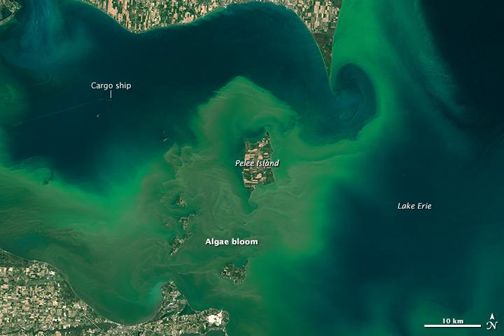
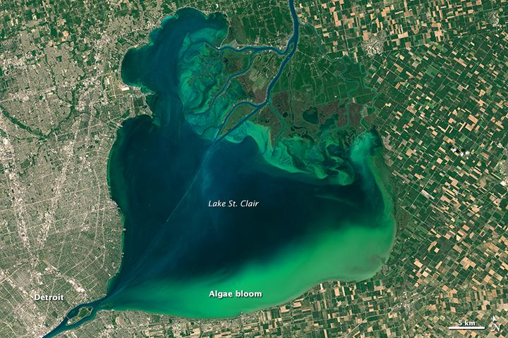
Source (including more information on the images):
NASA Earth Observatory https://earthobservatory.nasa.gov/IOTD/view.php?id=86327

