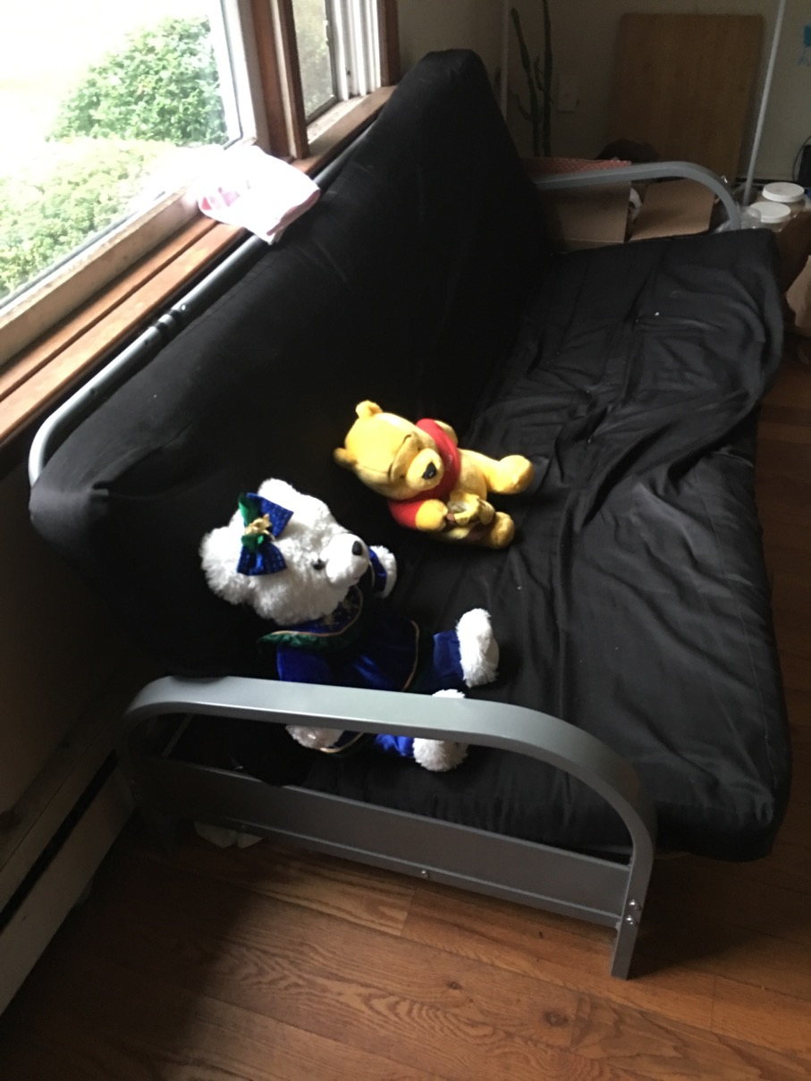

Couch, in very good state and used occasionally for 2.5 years.

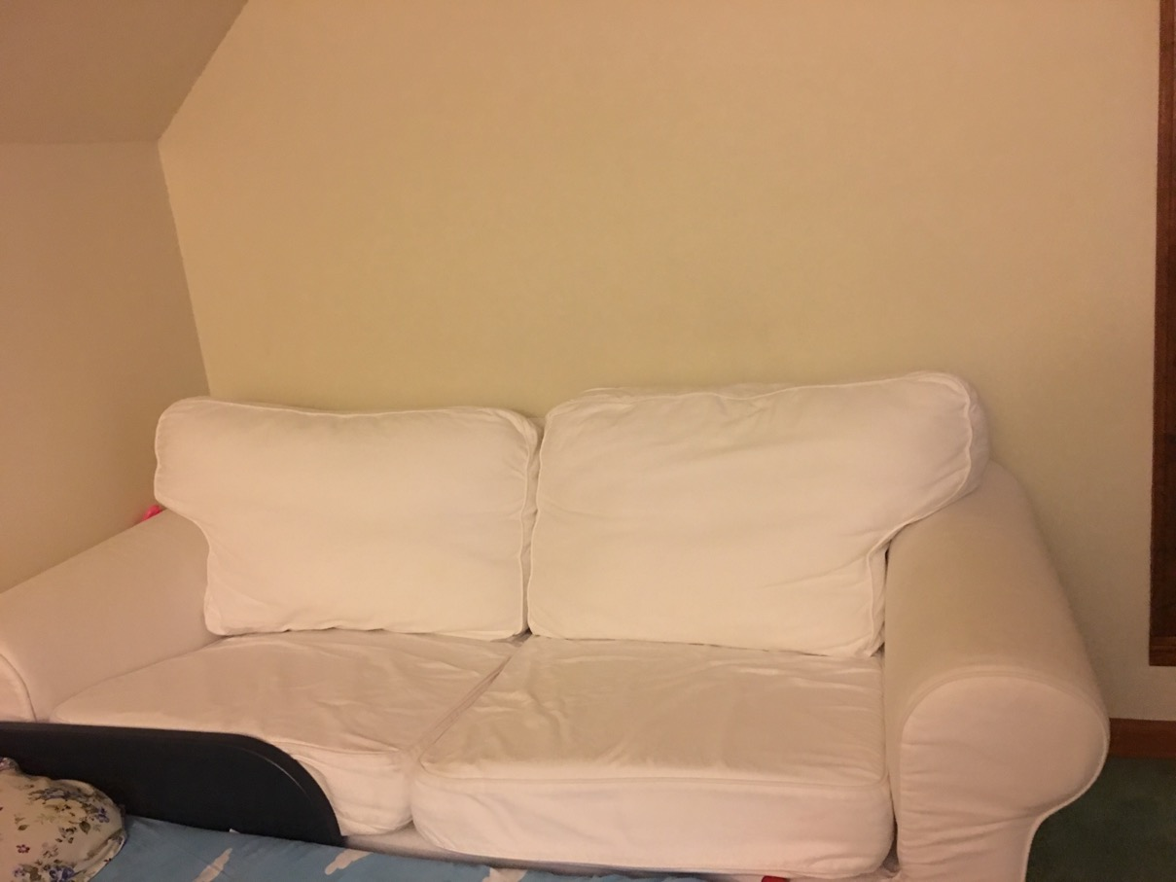

Couch in good state;

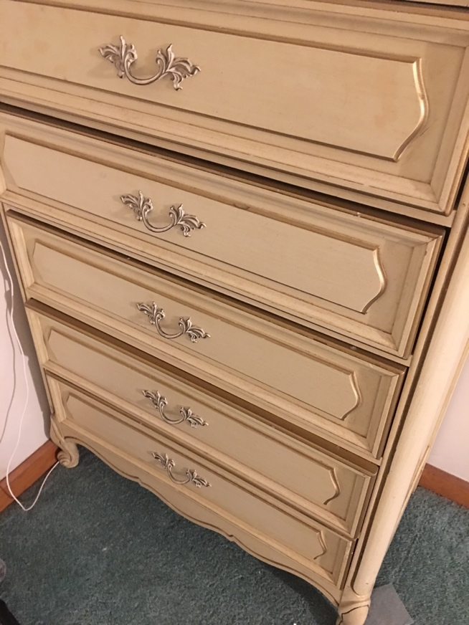

Wood clothes-Cabinet, in a very good state.

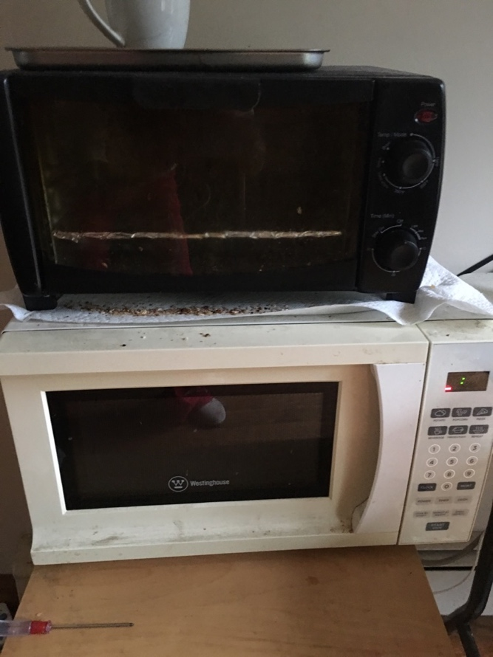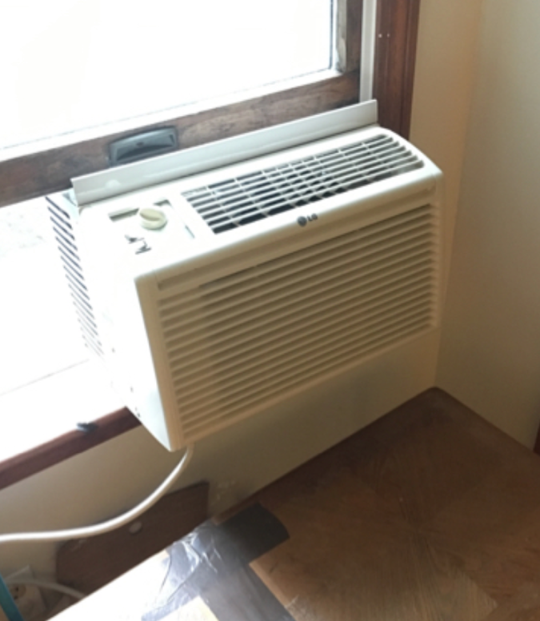
toaster oven & micro-wave & air-conditioner
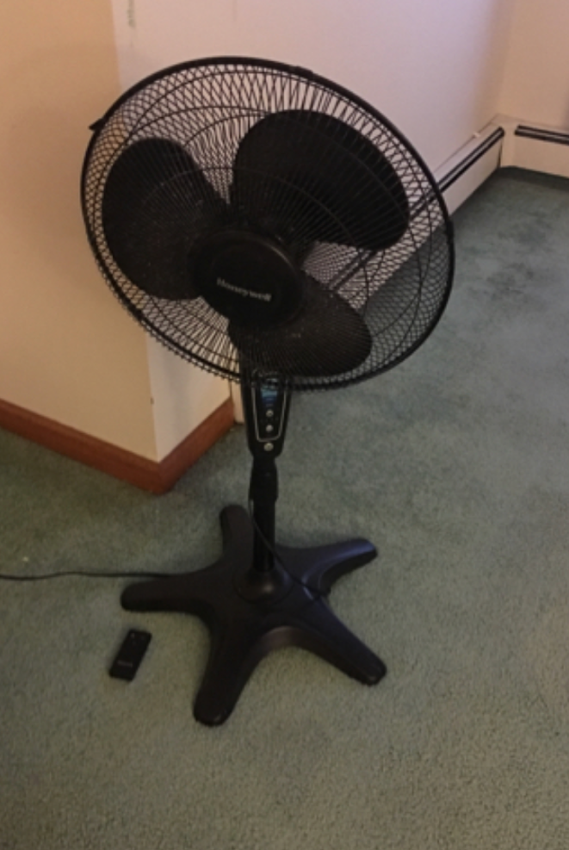
fan

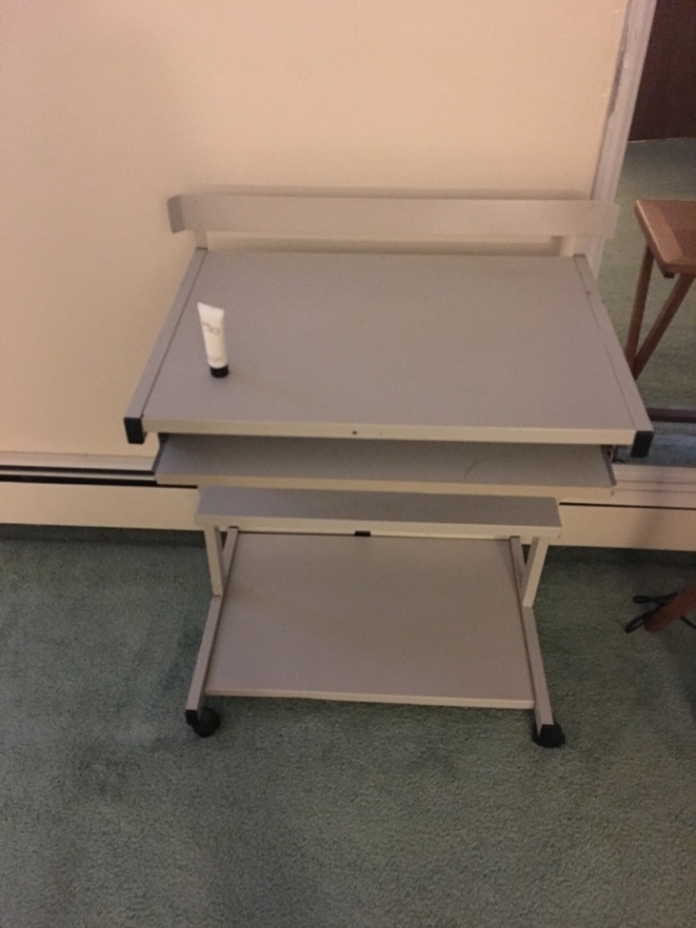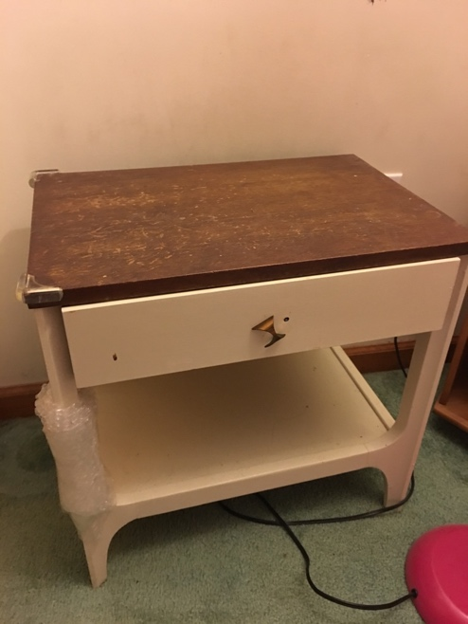
Computer-desk in good state; bed side cupboard
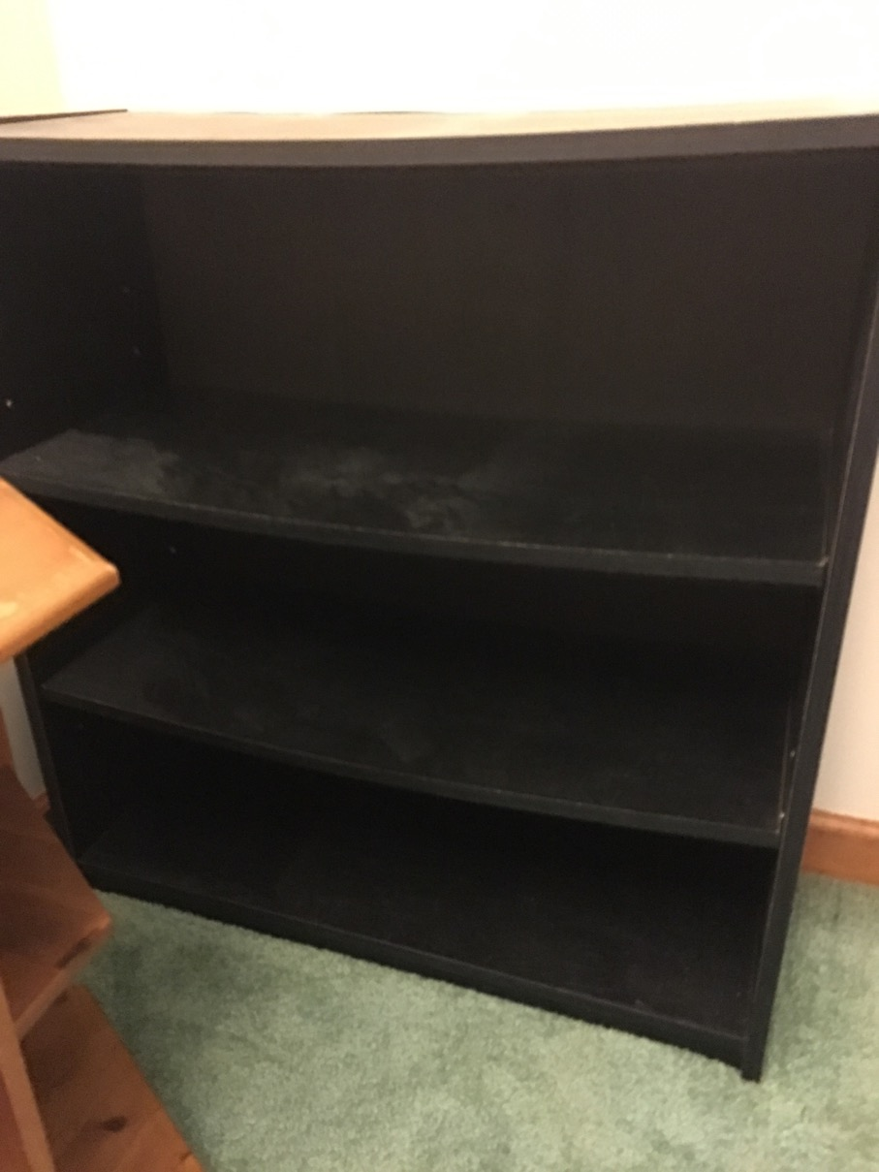
Wood shoe rack.

King size steel black bed frame with mattress. Frame in excellent condition (despite the small used marks on the mattress), used for less than a year; moving and have no space for it. Frame picture from website for the similar/same one,

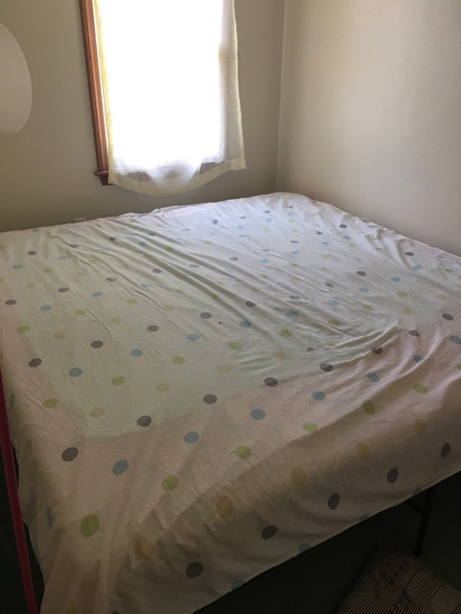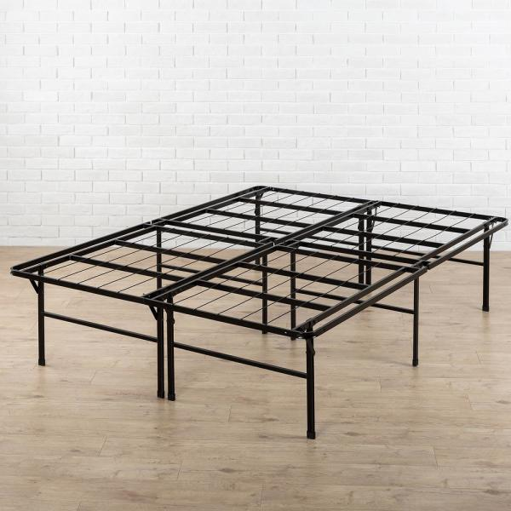

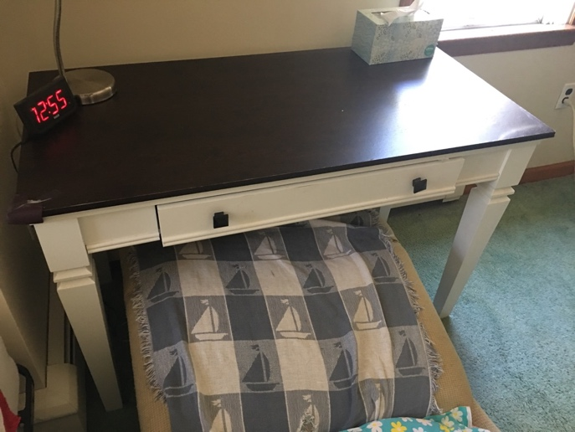

Desk in excellent condition

All the things are in good states, and can only be picked up by yourself at the apartment (Falmouth) before September 1, 2019, for free, or you can give whatever if you want.
Please contact me by email: jinli6059@gmail.com

