King size steel black bed frame with mattress. Frame in excellent condition (despite the small used marks on the mattress), used for less than a year; moving and have no space for it. $35
Frame picture from website for the similar/same one, amazon link: https://www.amazon.com/Zinus-SmartBase-Foundation-Replacement-Noise-Free/dp/B006MIVR06/ref=sr_1_3?keywords=King+size+steel+black+bed+frame&qid=1565283852&s=gateway&sr=8-3)

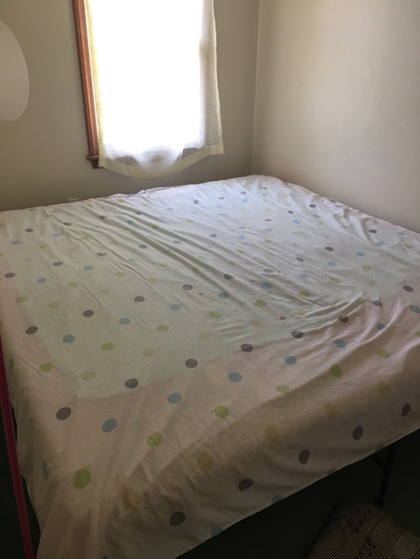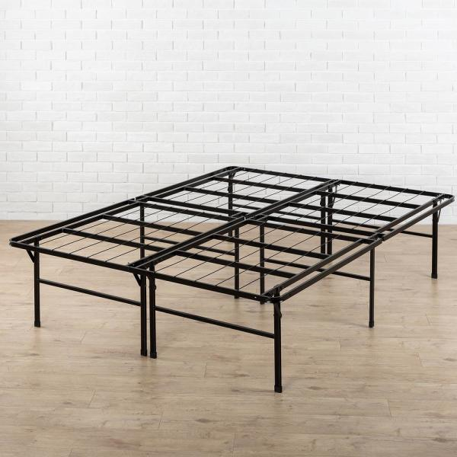

Desk in excellent condition, color: Espresso; size 110 cm long*60 cm wide*70 cm high, $35 (Some other chairs, closet, etc. can be given for free)
The desk on amazon link with similar shape and outline but smaller size (~92 cm long) and different color on the surface:
https://www.amazon.com/Convenience-Concepts-French-Country-36-Inch/dp/B00FDPLOU2/ref=sr_1_52?keywords=white%2Bwood%2Bdesk&qid=1565284062&s=gateway&sr=8-52&th=1

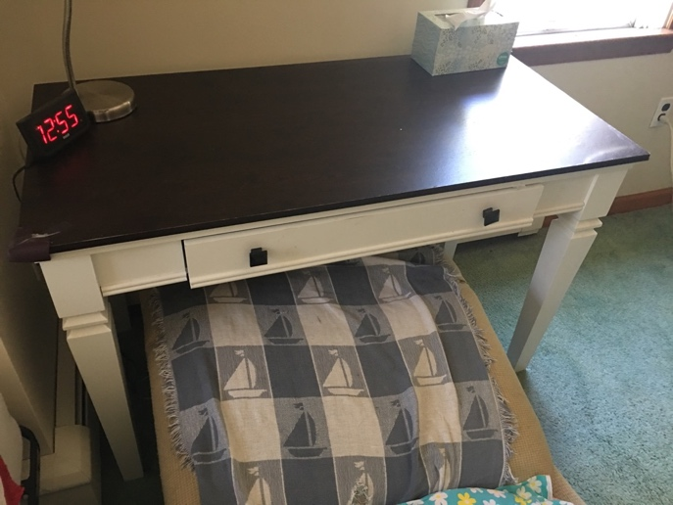

Stainless steel Mini Fridge in excellent condition, purchased 15 months ago, $35
Quite close to the linkage in best-buy (especially inside structure is almost exactly the same).
https://www.bestbuy.com/site/insignia-3-0-cu-ft-mini-fridge-stainless-steel/6203900.p?skuId=6203900

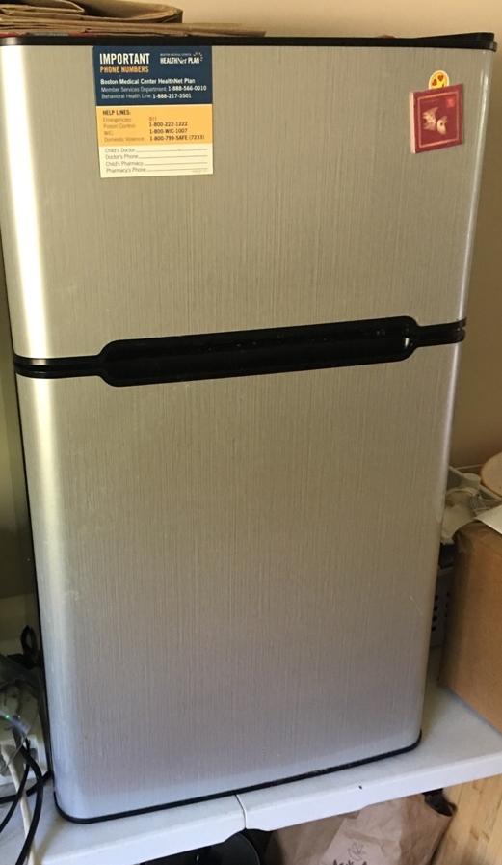

Vicks filer free, almost new from Walmart, bought in January 2019 and used for 2 weeks, 20$
https://www.walmart.com/ip/Vicks-Filter-Free-Cool-Mist-Humidifier-V4600-White/29765911

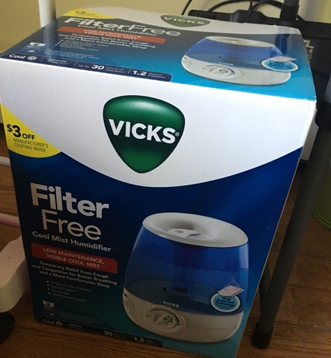

All the things can only be picked up by yourself at the apartment (02540 Falmouth MA)…before August 31, 2019…
please contact me by email: jinli6059@gmail.com

