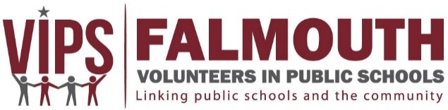

Press Release: Falmouth Volunteers In Public Schools (VIPS)
For Immediate Release: 5 September 2018
Contact: Tracey Crago, VIPS Director, (508) 548-1621, tcrago@falmouth.k12.ma.us

VIPS Announces Meeting for Volunteers Interested in School-based Mentoring

Falmouth Volunteers In Public Schools (VIPS) will be hosting an informational meeting for volunteers interested in learning more about its school-based mentoring programs. The session will be held Wednesday, September 19th at 1 p.m. in the Hermann Meeting Room at Falmouth Public Library.

Since 1994, Falmouth VIPS has overseen a one-to-one mentoring program that takes place during the school day. The program, called Project RISE (Raising Interest and Self-Esteem), matches trained volunteers with a student who will benefit from a consistent and positive mentoring relationship. Mentors meet with their mentee once a week for about an hour during the school day. At the information session on September 19th, interested volunteers will hear from program leader Shona Vitelli about students who are waiting to be matched with a mentor. Volunteers will also have the opportunity to meet current mentors who can share their experiences and answer questions.

Volunteer mentors are needed at all schools. At the elementary and middle school levels, students are selected to participate in Project RISE by teachers, school adjustment counselors, or parents who believe that these students would benefit from having a caring adult as a friend. Each year, students in need of a mentor are left unmatched because we do not have enough mentors. By spending an hour each week with a child in a one-on-one, trusting relationship, a mentor can change the direction that child takes in his or her life.
Mentors are also needed at the high school for students who may be having difficulty adjusting to the high school environment where they are faced with many difficult challenges and decisions.

The strength of the mentor—mentee relationship gives the student the tools he or she may need to become more self-assured and able to withstand adverse peer pressure. Students involved in school-based mentoring
programs found they: enjoyed spending time with their mentors; could count on their mentors; learned new
things; participated in a variety of experiences; and wanted to continue in the program. Mentors noted that they: enjoyed being with their mentees; had learned from their mentees; and believed that mentees had obtained new information regarding careers, higher education, and problem-solving techniques.

Mentoring is rewarding! Please join us on September 19th or contact VIPS at (508) 548-1621 or send an email to mentor@falmouth.k12.ma.us. New mentors are provided training prior to starting and throughout the school year.

###

Falmouth VIPS, 874 Gifford St., Falmouth, MA 02540 (508) 548-1621 www.falmouthvips.org vips@falmouth.k12.ma.us

